24
2A | 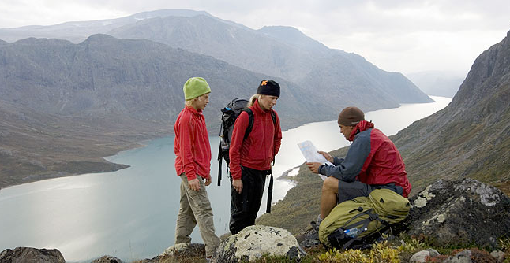
The following ideas may help you:

- Place
- Weather
- Environment/Nature
- Atmosphere
- Possible problems
- Other
2B | 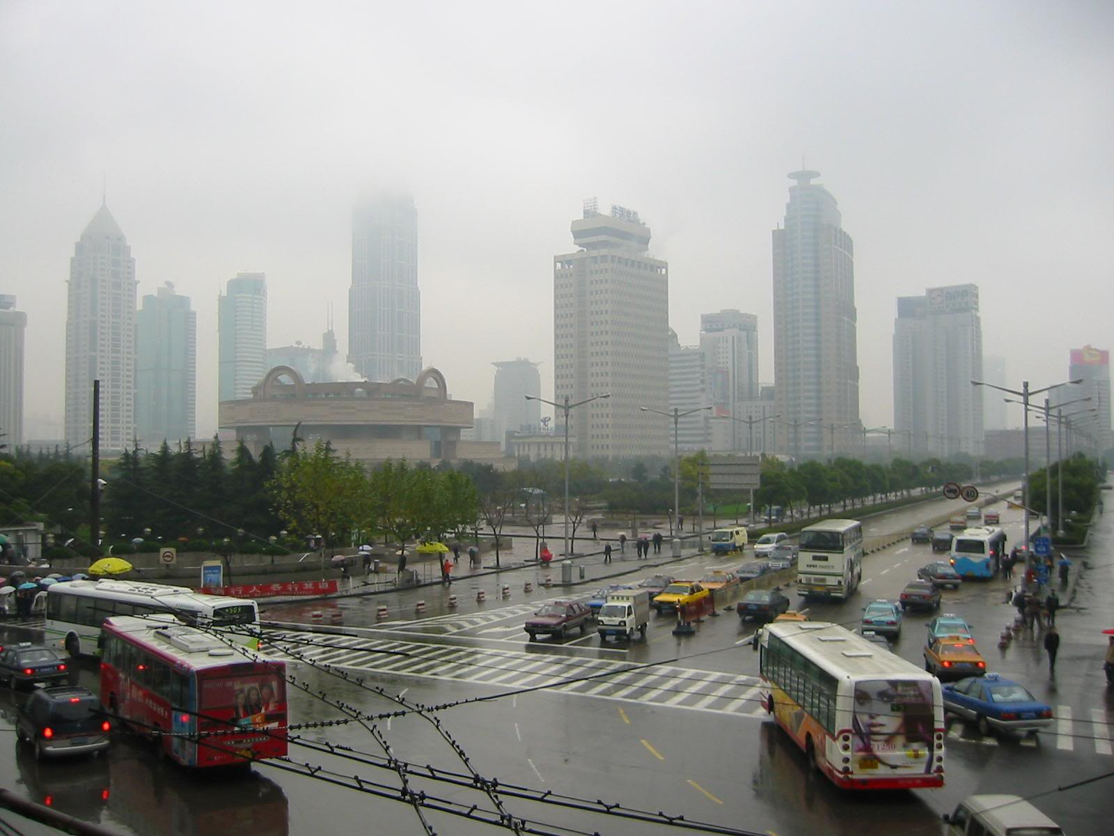
PART TWO | Nature and environment

B

