23
2A | 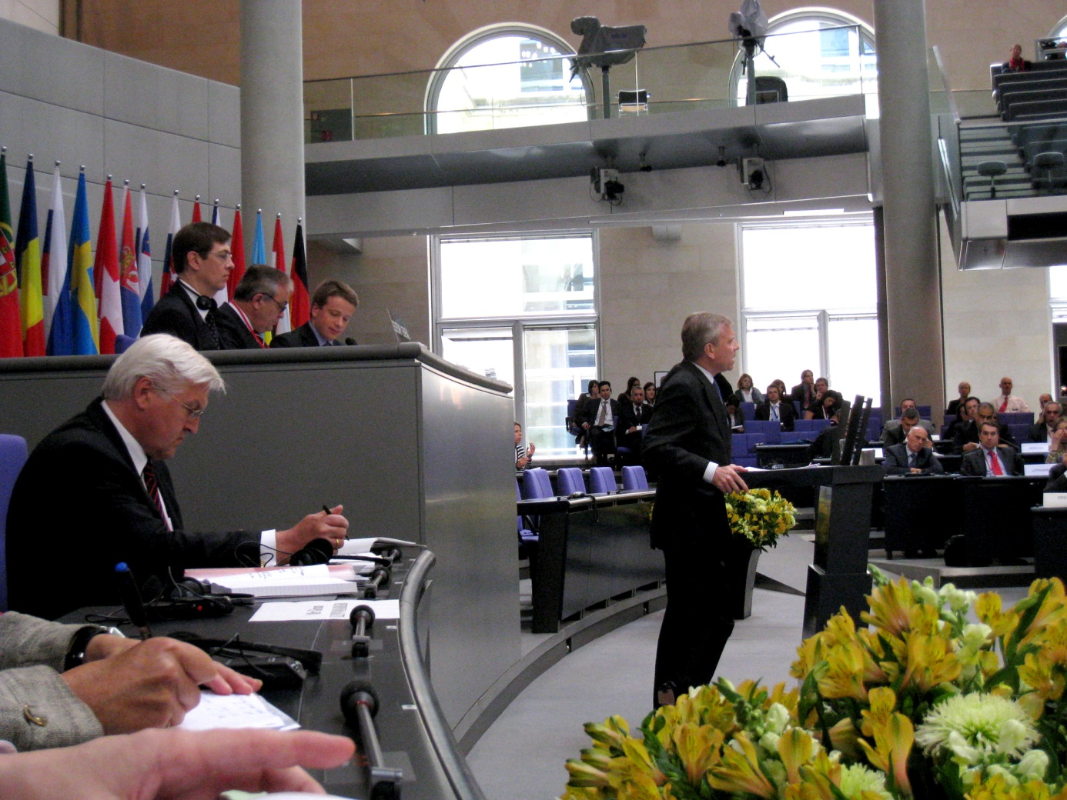
The following ideas may help you:

- Place
- Occasion
- People
- Activities
- Atmosphere
- Other
2B | 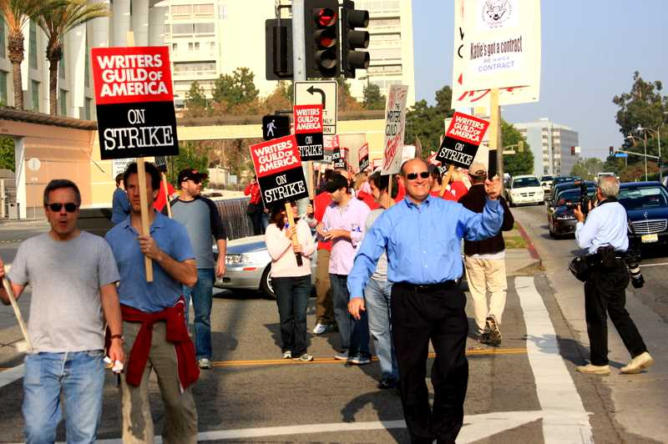
PART TWO | Politics

B

