22
2A | 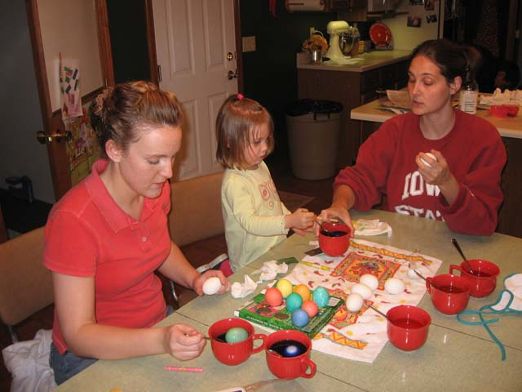
The following ideas may help you:

- Place
- People
- Activities
- Celebration
- Atmosphere
- Other
2B | 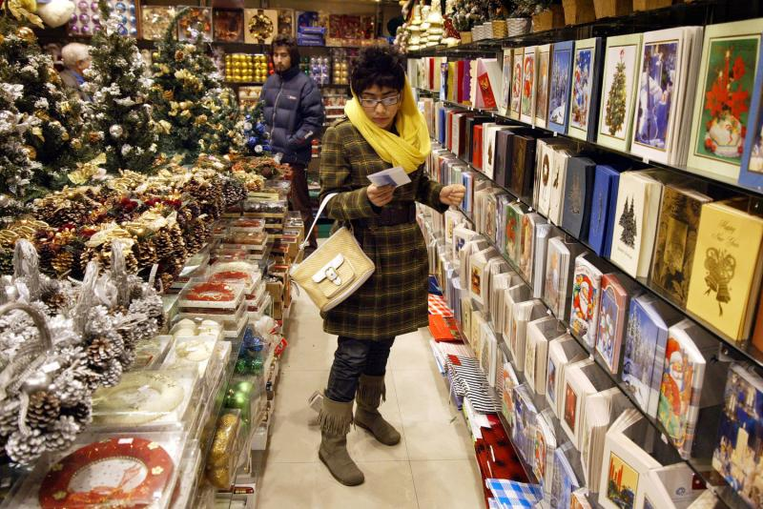
PART TWO | Customs and traditions

B

