21
PART TWO | Mass media
2A | 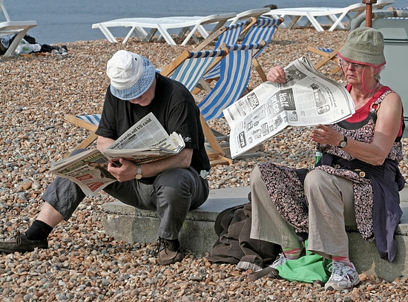
The following ideas may help you:

- Place
- People (age, appearance, clothes)
- Activities
- Media
- Advantages/Disadvantages
- Other
2B | 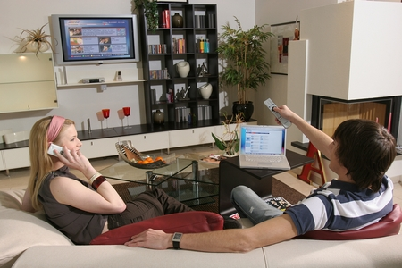

B

