20
2A | 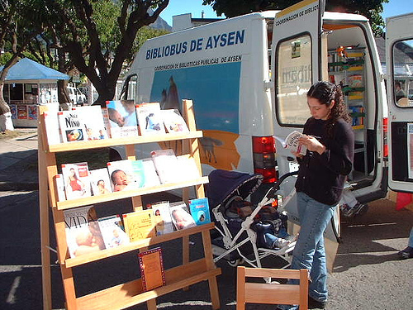
The following ideas may help you:

- Place
- People
- Activities
- Advantages/Disadvantages
- Atmosphere
- Other
2B | 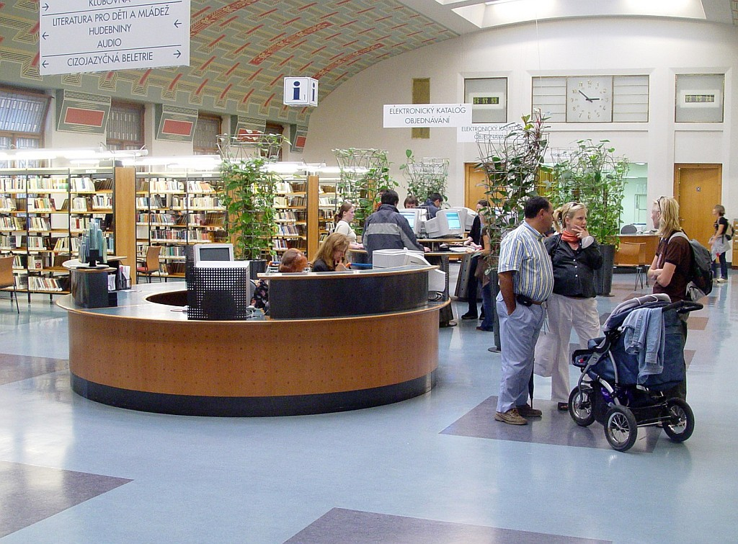
PART TWO | Services – library

B

