19
2A | 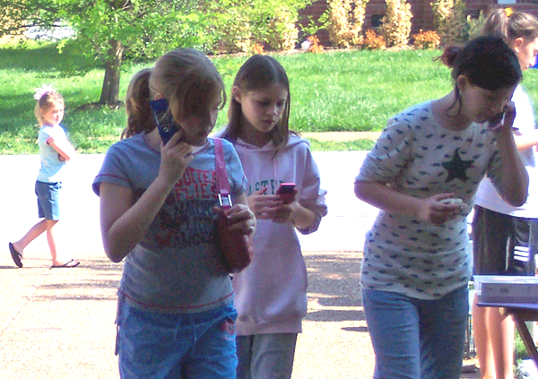
The following ideas may help you:

- Place
- People (age, gender, clothes)
- Activities
- Means of communication
- Atmosphere
- Other
2B | 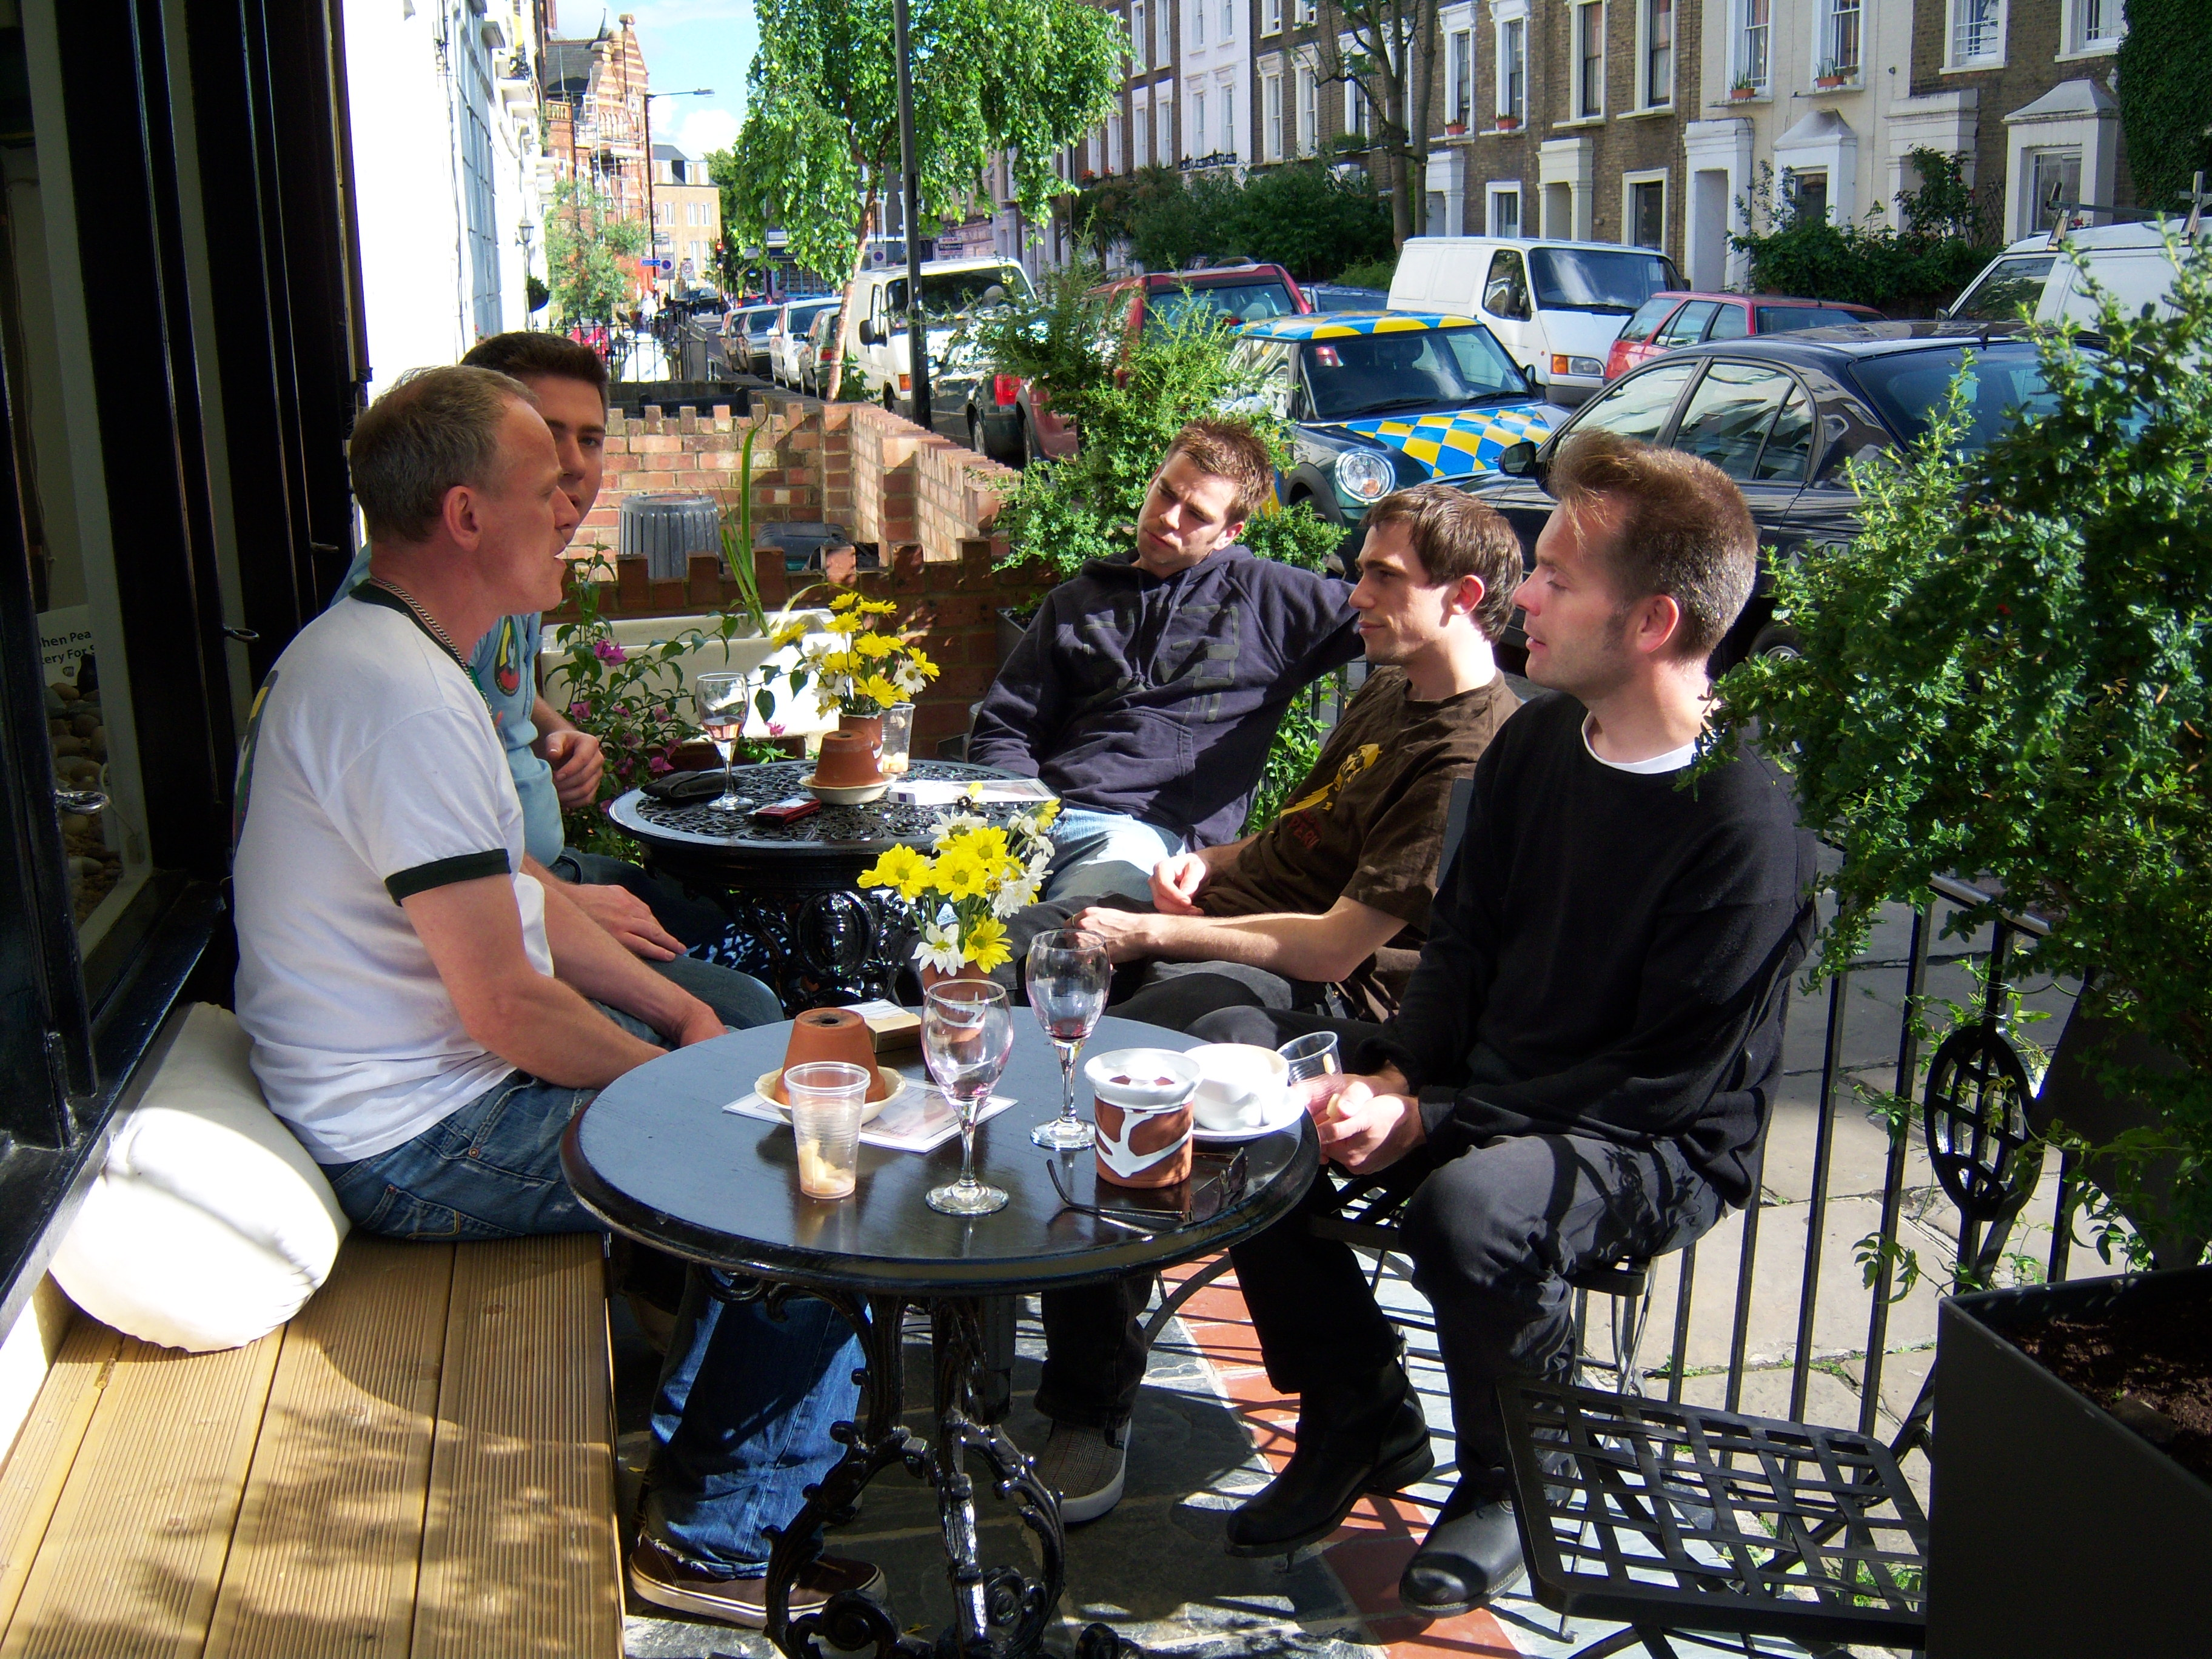
PART TWO | Communication

B

