Hello. (Sit down, please. Would you tell me your task sheet number so I can check it, please?)
18
TOPIC: Job and occupation
INTRODUCTION | 0,5 min.

First, could you briefly introduce yourself to the committee?

Thank you.
Now, let’s go to Part One.
I am going to ask you some questions about the topic Jobs. If possible, give detailed answers. If you don’t understand a question, please ask me to repeat it.
PART ONE (3–5 Qs) | Jobs | 2,5 min.
Are you ready?

- Could you imagine having your parents’ job? Why?/Why not?
- Which do you think is more important: to make a lot of money or to enjoy your job? Why?
- What job do you wish to have in the future and why?
- What qualities should a journalist/manager/teacher/doctor have to make a successful career? Why?
- Should students work for money while they are studying? Why?/Why not?
- If you could own/run your own business, what would it be? Why?

Thank you. Now, let’s go to Part Two.
Look at pictures 2A and 2B on the separate handout and compare and contrast them in detail.
PART TWO | Jobs | 4 min.
Task One | 2,5 min.
Are you ready?
Thank you. Now, let’s go to Task Two.
- Place  - People (appearance, clothes)  - Activities  - Job  - Skills (qualifications, training)  - Other | - What are the advantages/disadvantages of working on the farm/on the plane?  - Which of the jobs is more dangerous/stressful/repetitive? Why?  - Which of these would you prefer? Why?

Read aloud the statement and express and justify your opinion on it.
Task Two | 1,5 min.
The people who can help students most in choosing their future career are their parents. | - Do you agree or disagree with the statement? Why?  - Present an example and/or talk about your own experience.
B

Thank you. Now, let’s go to Part Three.

Now, please take the student's task sheet for part three.
PART THREE |  | 5 min.
Now we are going to talk together using pictures 4A–4C. Imagine the following situation:
PART FOUR | Summer job in England | 3 min.
I am your English speaking friend and we met at an English language course in England. The course is about to end and we would like to stay in England a bit longer, but we need to earn some money for travelling. We should discuss the advantages and disadvantages of the jobs and then agree on the most suitable one. You should start the dialogue. Are you ready?
4A | 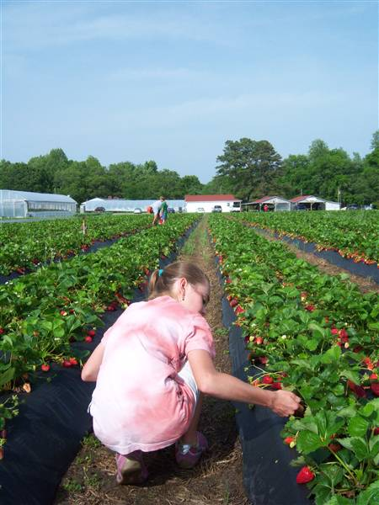 | 4B | 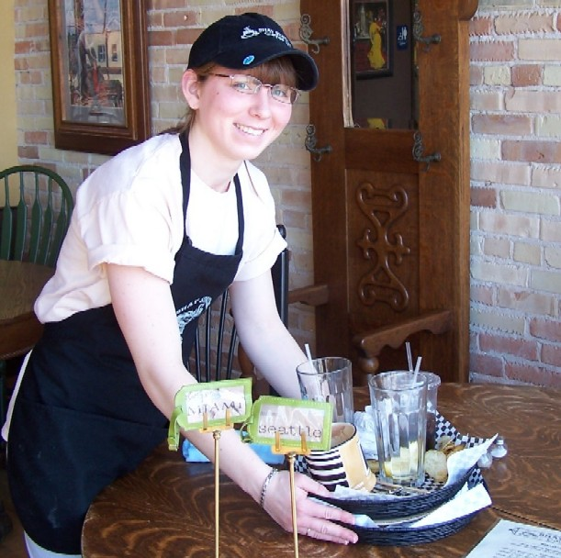
 | picking strawberries |  | waiter/waitress
4C |  | 4D | Other?
- Job  - Money  - Working conditions  - Working hours  - Skills needed for the job  - Other | - I don’t like this kind of job. It’s too physically demanding. / You can get backache from doing this job.  - How about working as a life guard at a swimming pool/window cleaner/...?  - We won’t earn much money doing this job.  - I don’t like working outside/inside.  - I can’t count well. I’m not suitable for working as a shop assistant.  - So what have we agreed on?
B

shop assistant

Thank you. That is the end of the examination.

