The examiner is going to ask you some questions. Please answer the questions in as much detail as possible. If you don’t understand a question, please ask the examiner to repeat it.
18
TOPIC: Job and occupation
PART ONE (2,5 min.) | Jobs
Part Two consists of two tasks.
PART TWO (4 min.) | Jobs
Take the separate handout with pictures 2A and 2B. The pictures show two different jobs.
Task One | 2,5 min.
Look at the pictures and compare and contrast them in detail.
The following ideas may help you:

- Place
- People (appearance, clothes)
- Activities
- Job
- Skills (qualifications, training)
- Other

Prepare to express and justify your opinion on the following statement.
Task Two | 1,5 min.

The people who can help students most in choosing their future career are their parents.
The following ideas may help you:
B

- Do you agree or disagree with the statement? Why?
- Present an example and/or talk about your own experience.
Take the student's task sheet for PART THREE.
In Part Four of the exam, you and the examiner are going to talk together using pictures 4A – 4C. Imagine the following situation:
PART THREE (5 min.)
PART FOUR (3 min.) | Summer job in England
You are in England attending an English language course and you meet a new friend. The course is about to end, but you and your friend would like to stay in England and travel. However, you don’t have enough money and you need to find a job. You should discuss which job to take and agree on the most suitable one. The examiner will play the role of your friend. You should start the dialogue.

The following ideas may help you:
B

- Job
- Money
- Working conditions
- Working hours
- Skills needed for the job
- Other

The following pictures may help you:

shop assistant
4A | 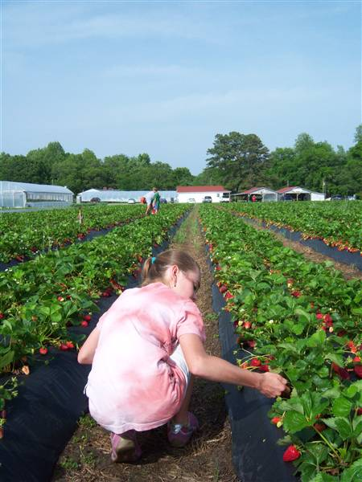 | 4B | 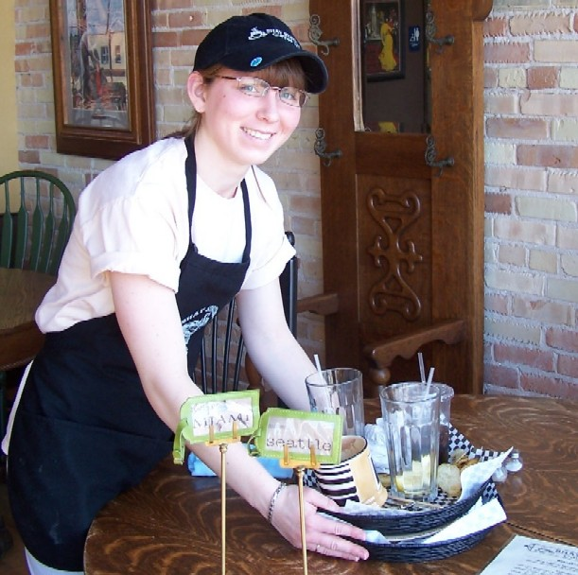
 | picking strawberries |  | waiter/waitress
4C |  | 4D | Other?

