18
2A | 
The following ideas may help you:

- Place
- People (appearance, clothes, etc.)
- Activities
- Job
- Skills (qualification, training)
- Other
2B | 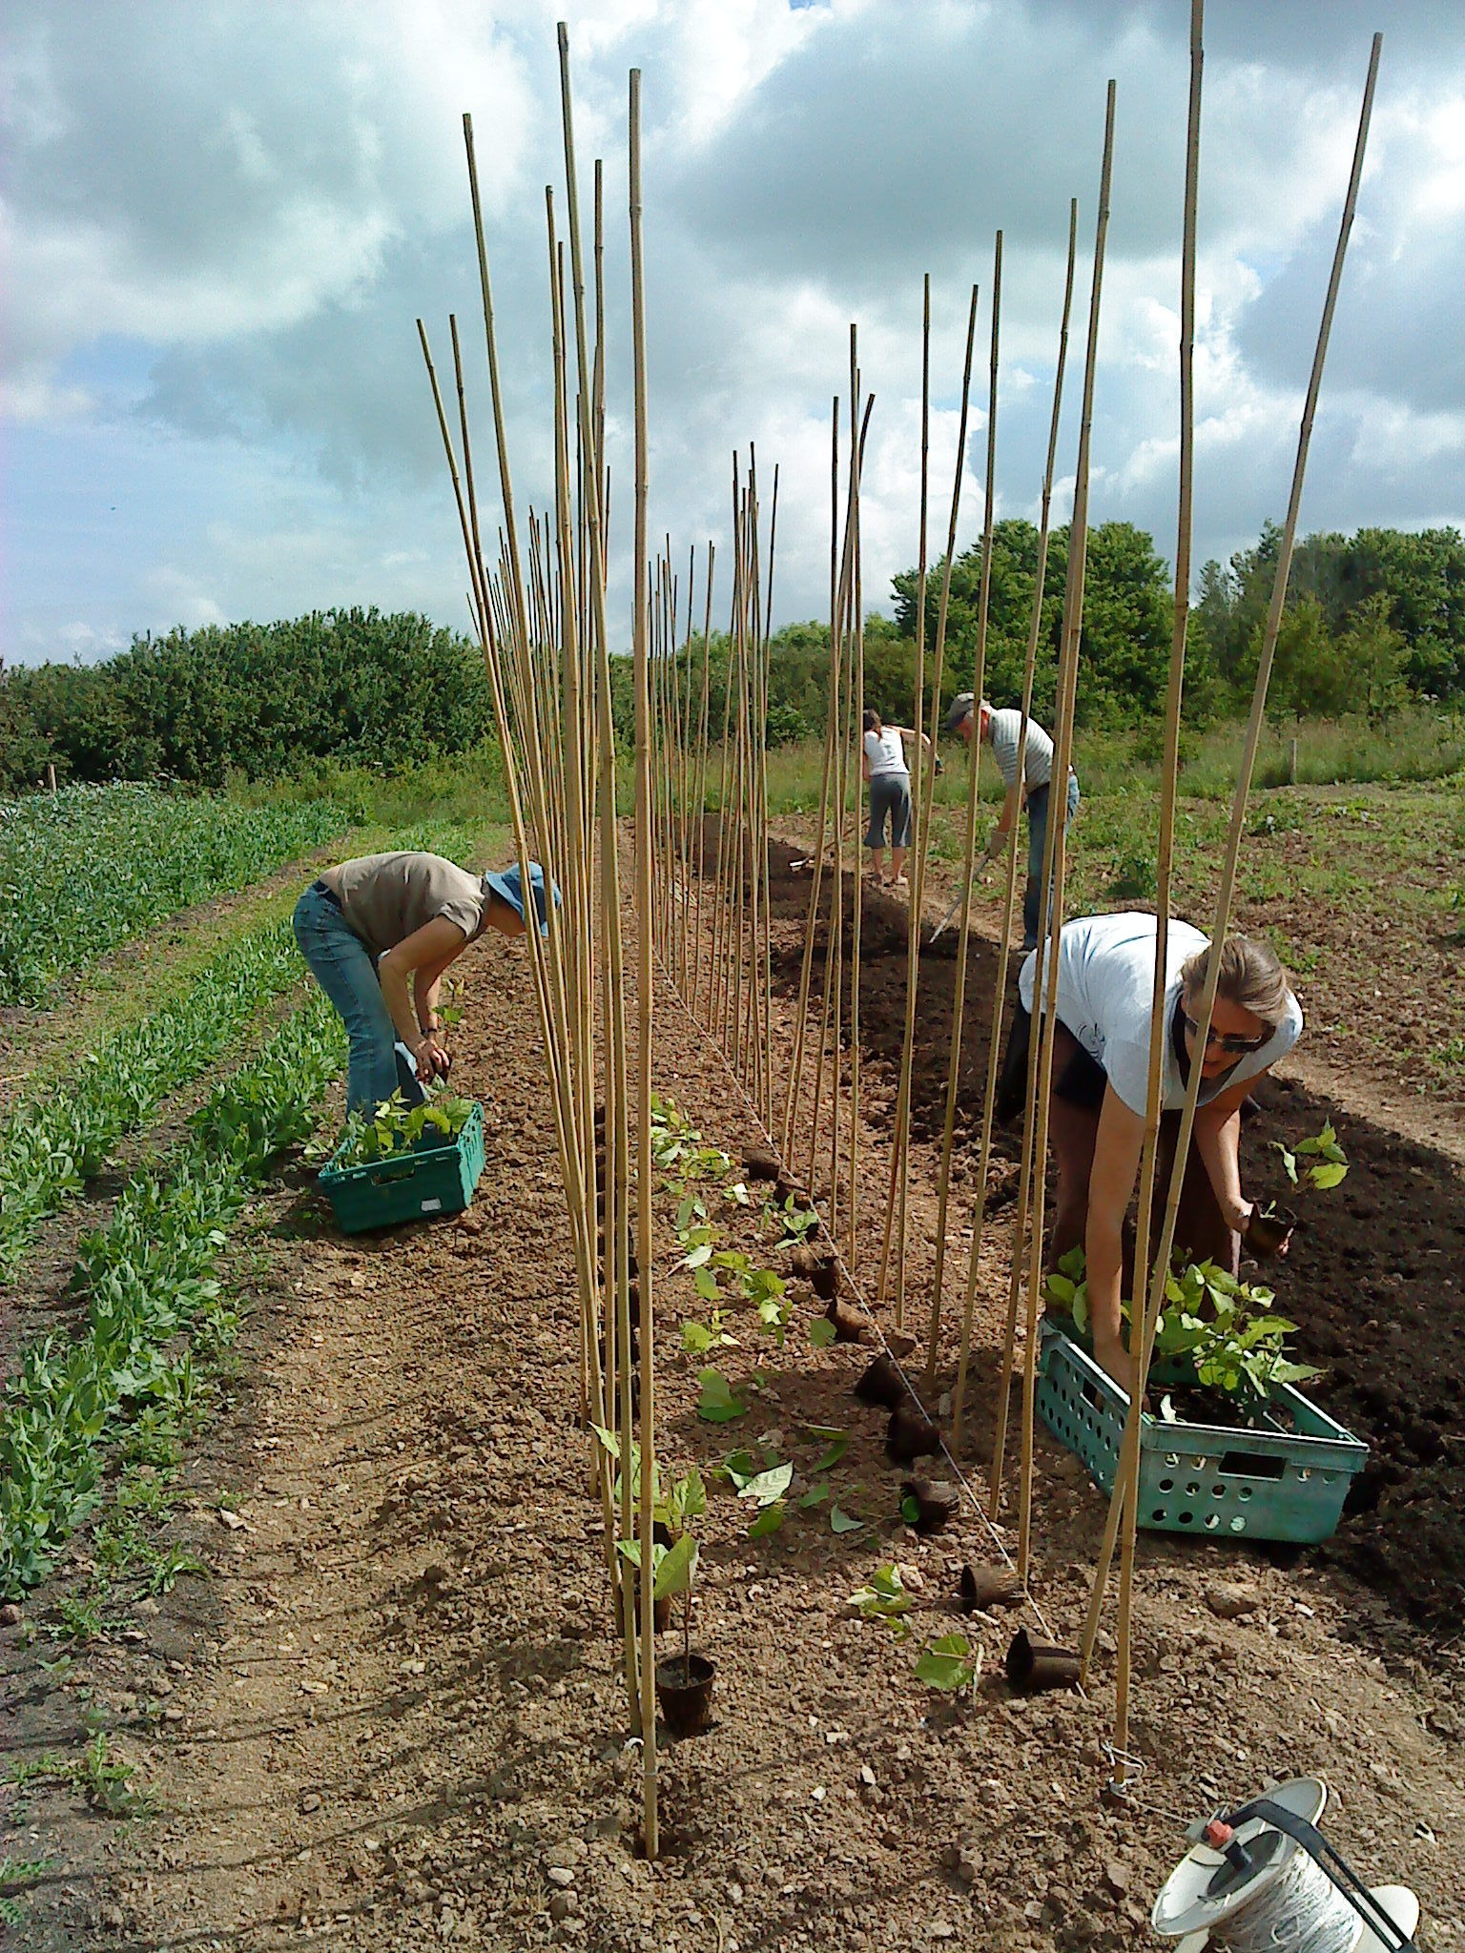
PART TWO | Jobs

B

