17
2A | 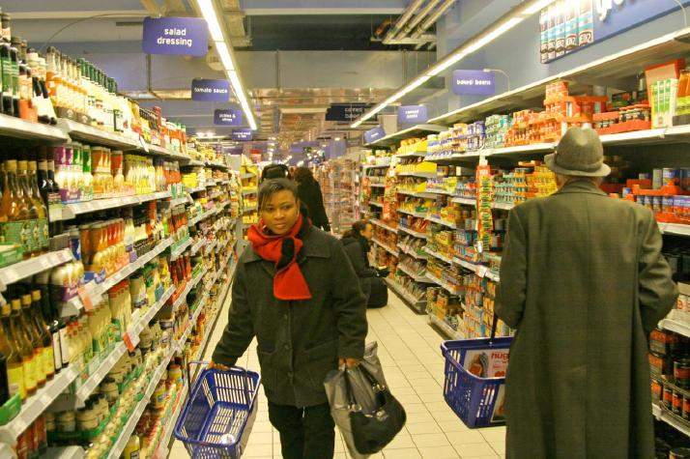
The following ideas may help you:

- Location
- People (clothes, appearance, etc.)
- Things they buy
- Price
- Atmosphere
- Other
2B | 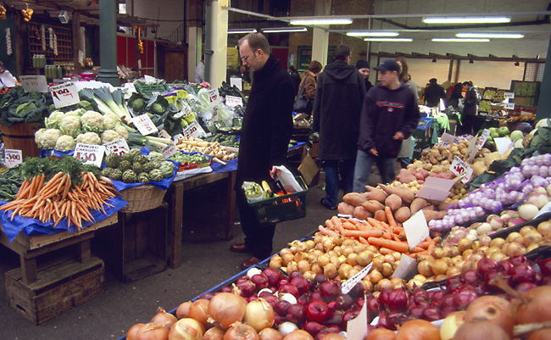
PART TWO | Shopping

B

