16
2A | 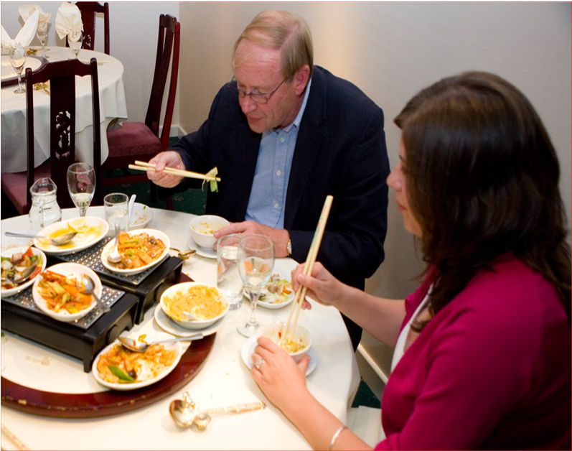
The following ideas may help you:

- Location/Place
- People (appearance, clothes, etc.)
- Food
- Table manners
- Price
- Other
2B | 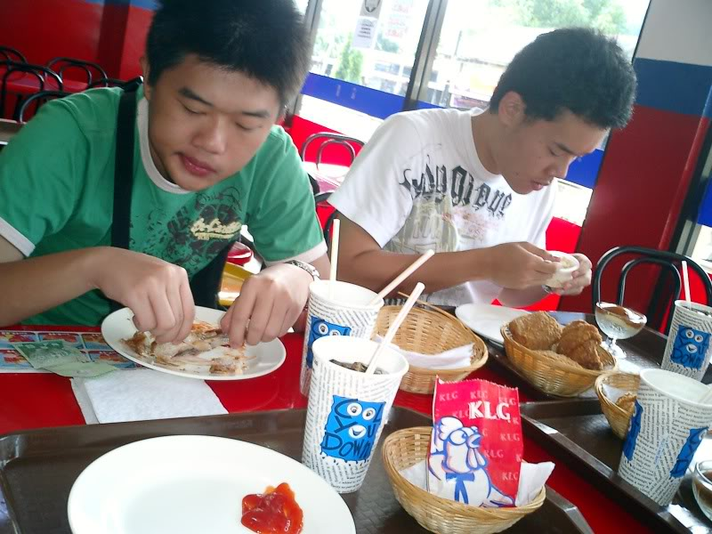
PART TWO | Restaurant

B

