15
2A | 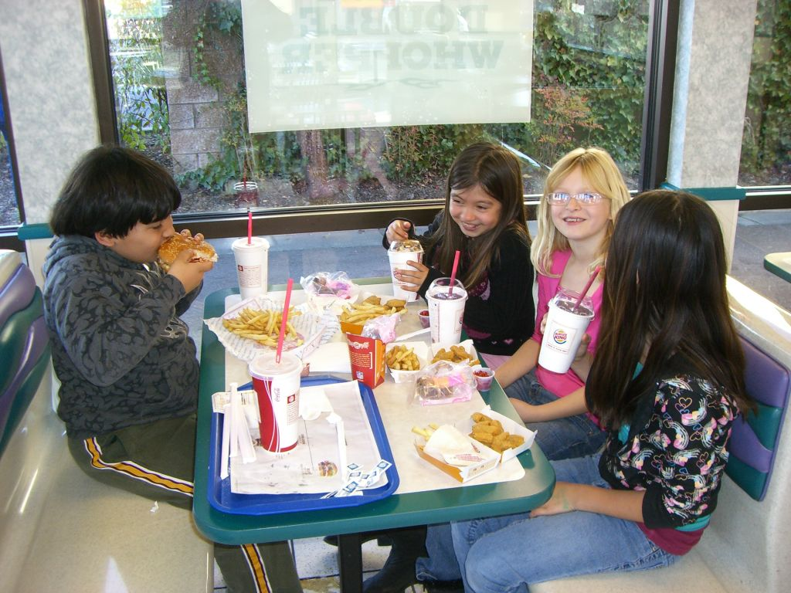
The following ideas may help you:

- Place
- People (appearance, age, clothes, etc.)
- Food and drinks
- Price/Service
- Atmosphere
- Other
2B | 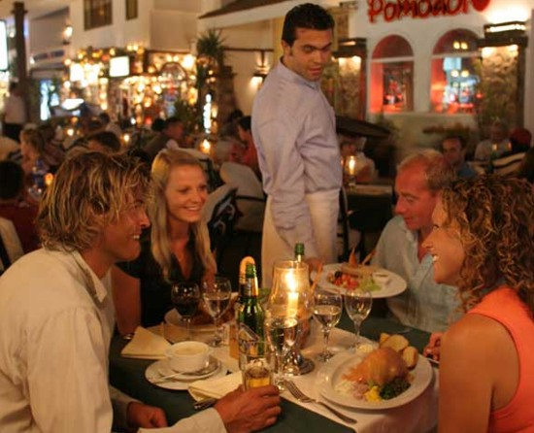
PART TWO | Restaurants

B

