14
PART TWO | Healthy lifestyle
2A | 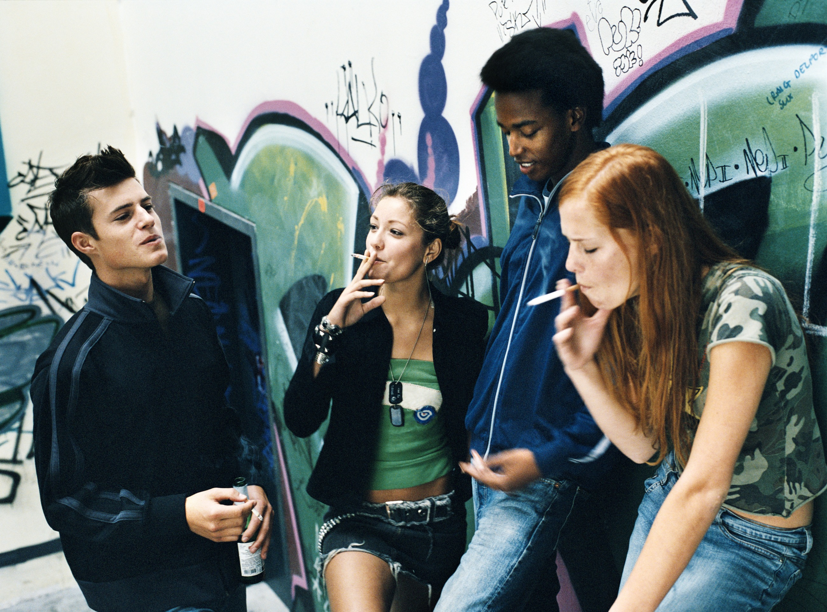
The following ideas may help you:

- Place
- People (age, appearance, clothes)
- Activities
- Lifestyle
- Atmosphere
- Other
2B | 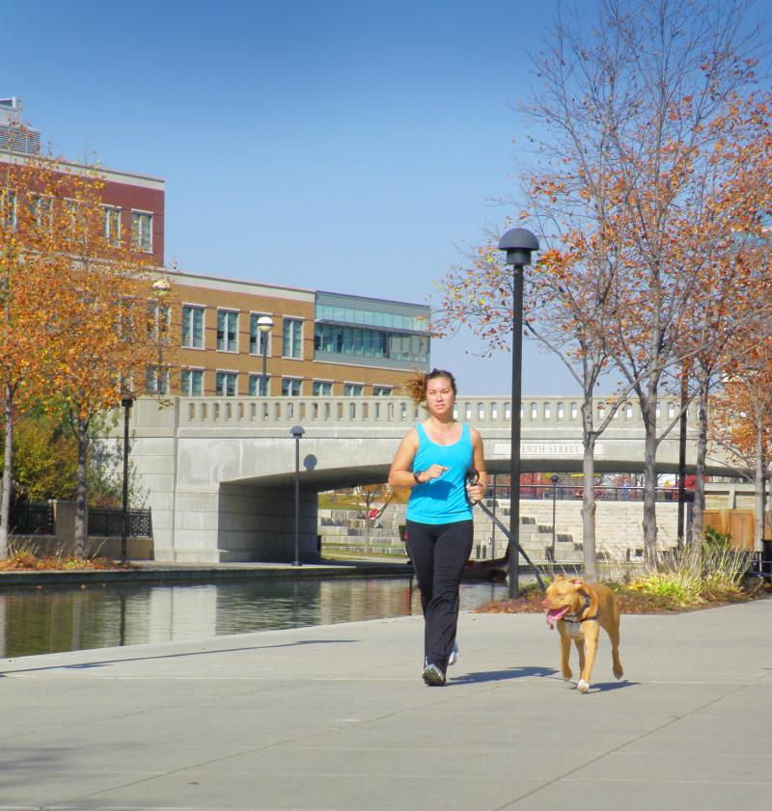

B

