13
PART TWO | Transport
2A | 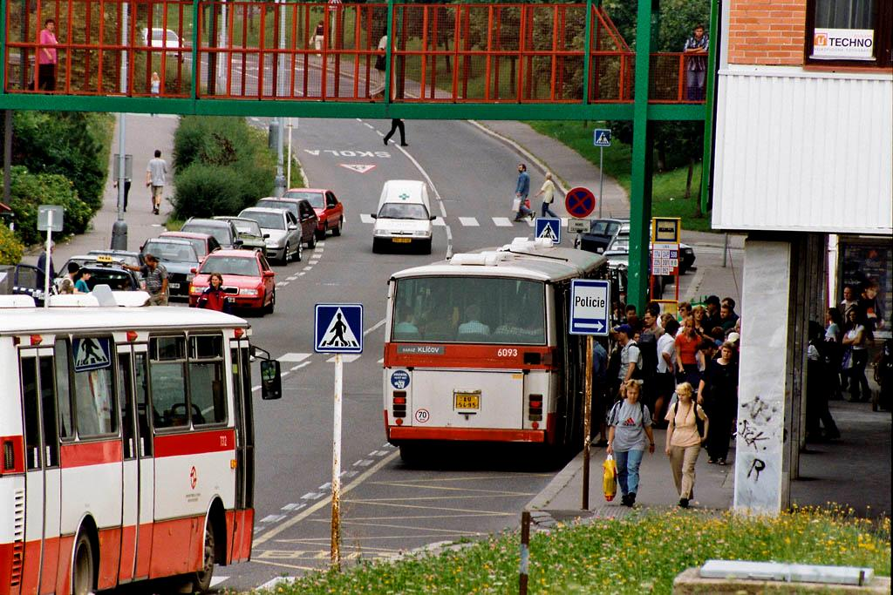
The following ideas may help you:

- Place
- People
- Means of transport
- Speed/Comfort
- Health/Safety
- Other
2B | 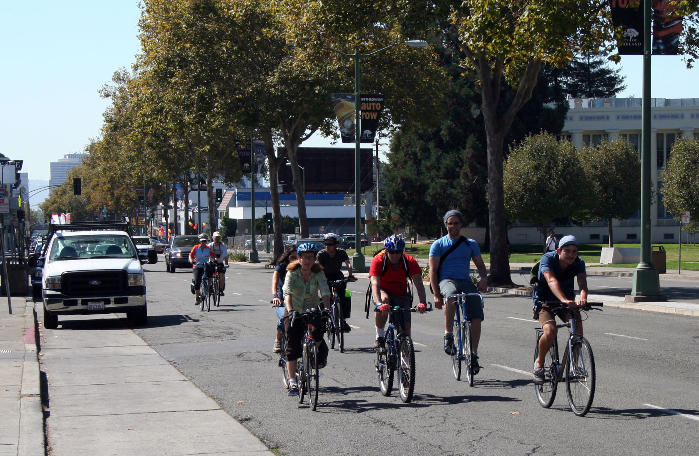

B

