12
2A | 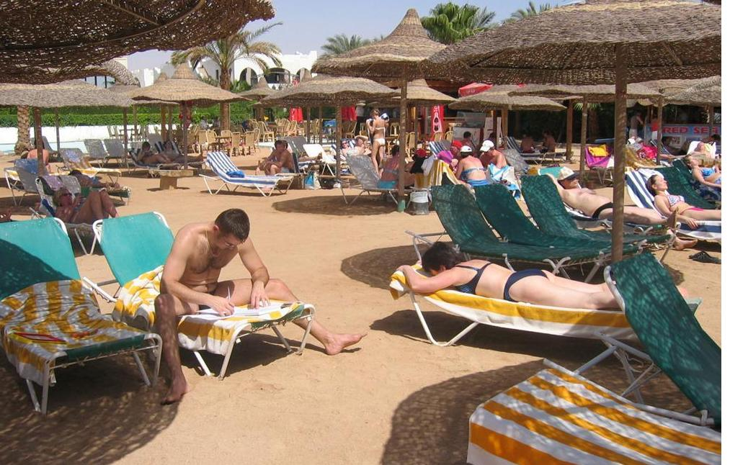
The following ideas may help you:

- Place
- Weather/Season of the year
- People (appearance, clothes, age, etc.)
- Activities
- Atmosphere
- Other
2B | 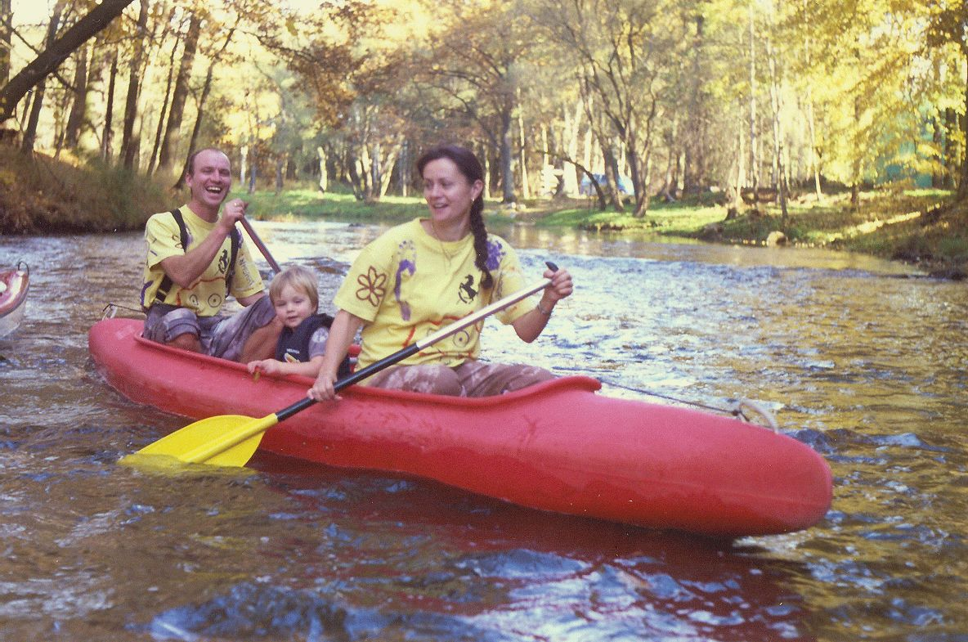
PART TWO | Holidays and tourism

B

