11
2A | 
The following ideas may help you:

- Place
- People (age, appearance, clothes)
- Relationships
- Activities
- Atmosphere
- Other
2B | 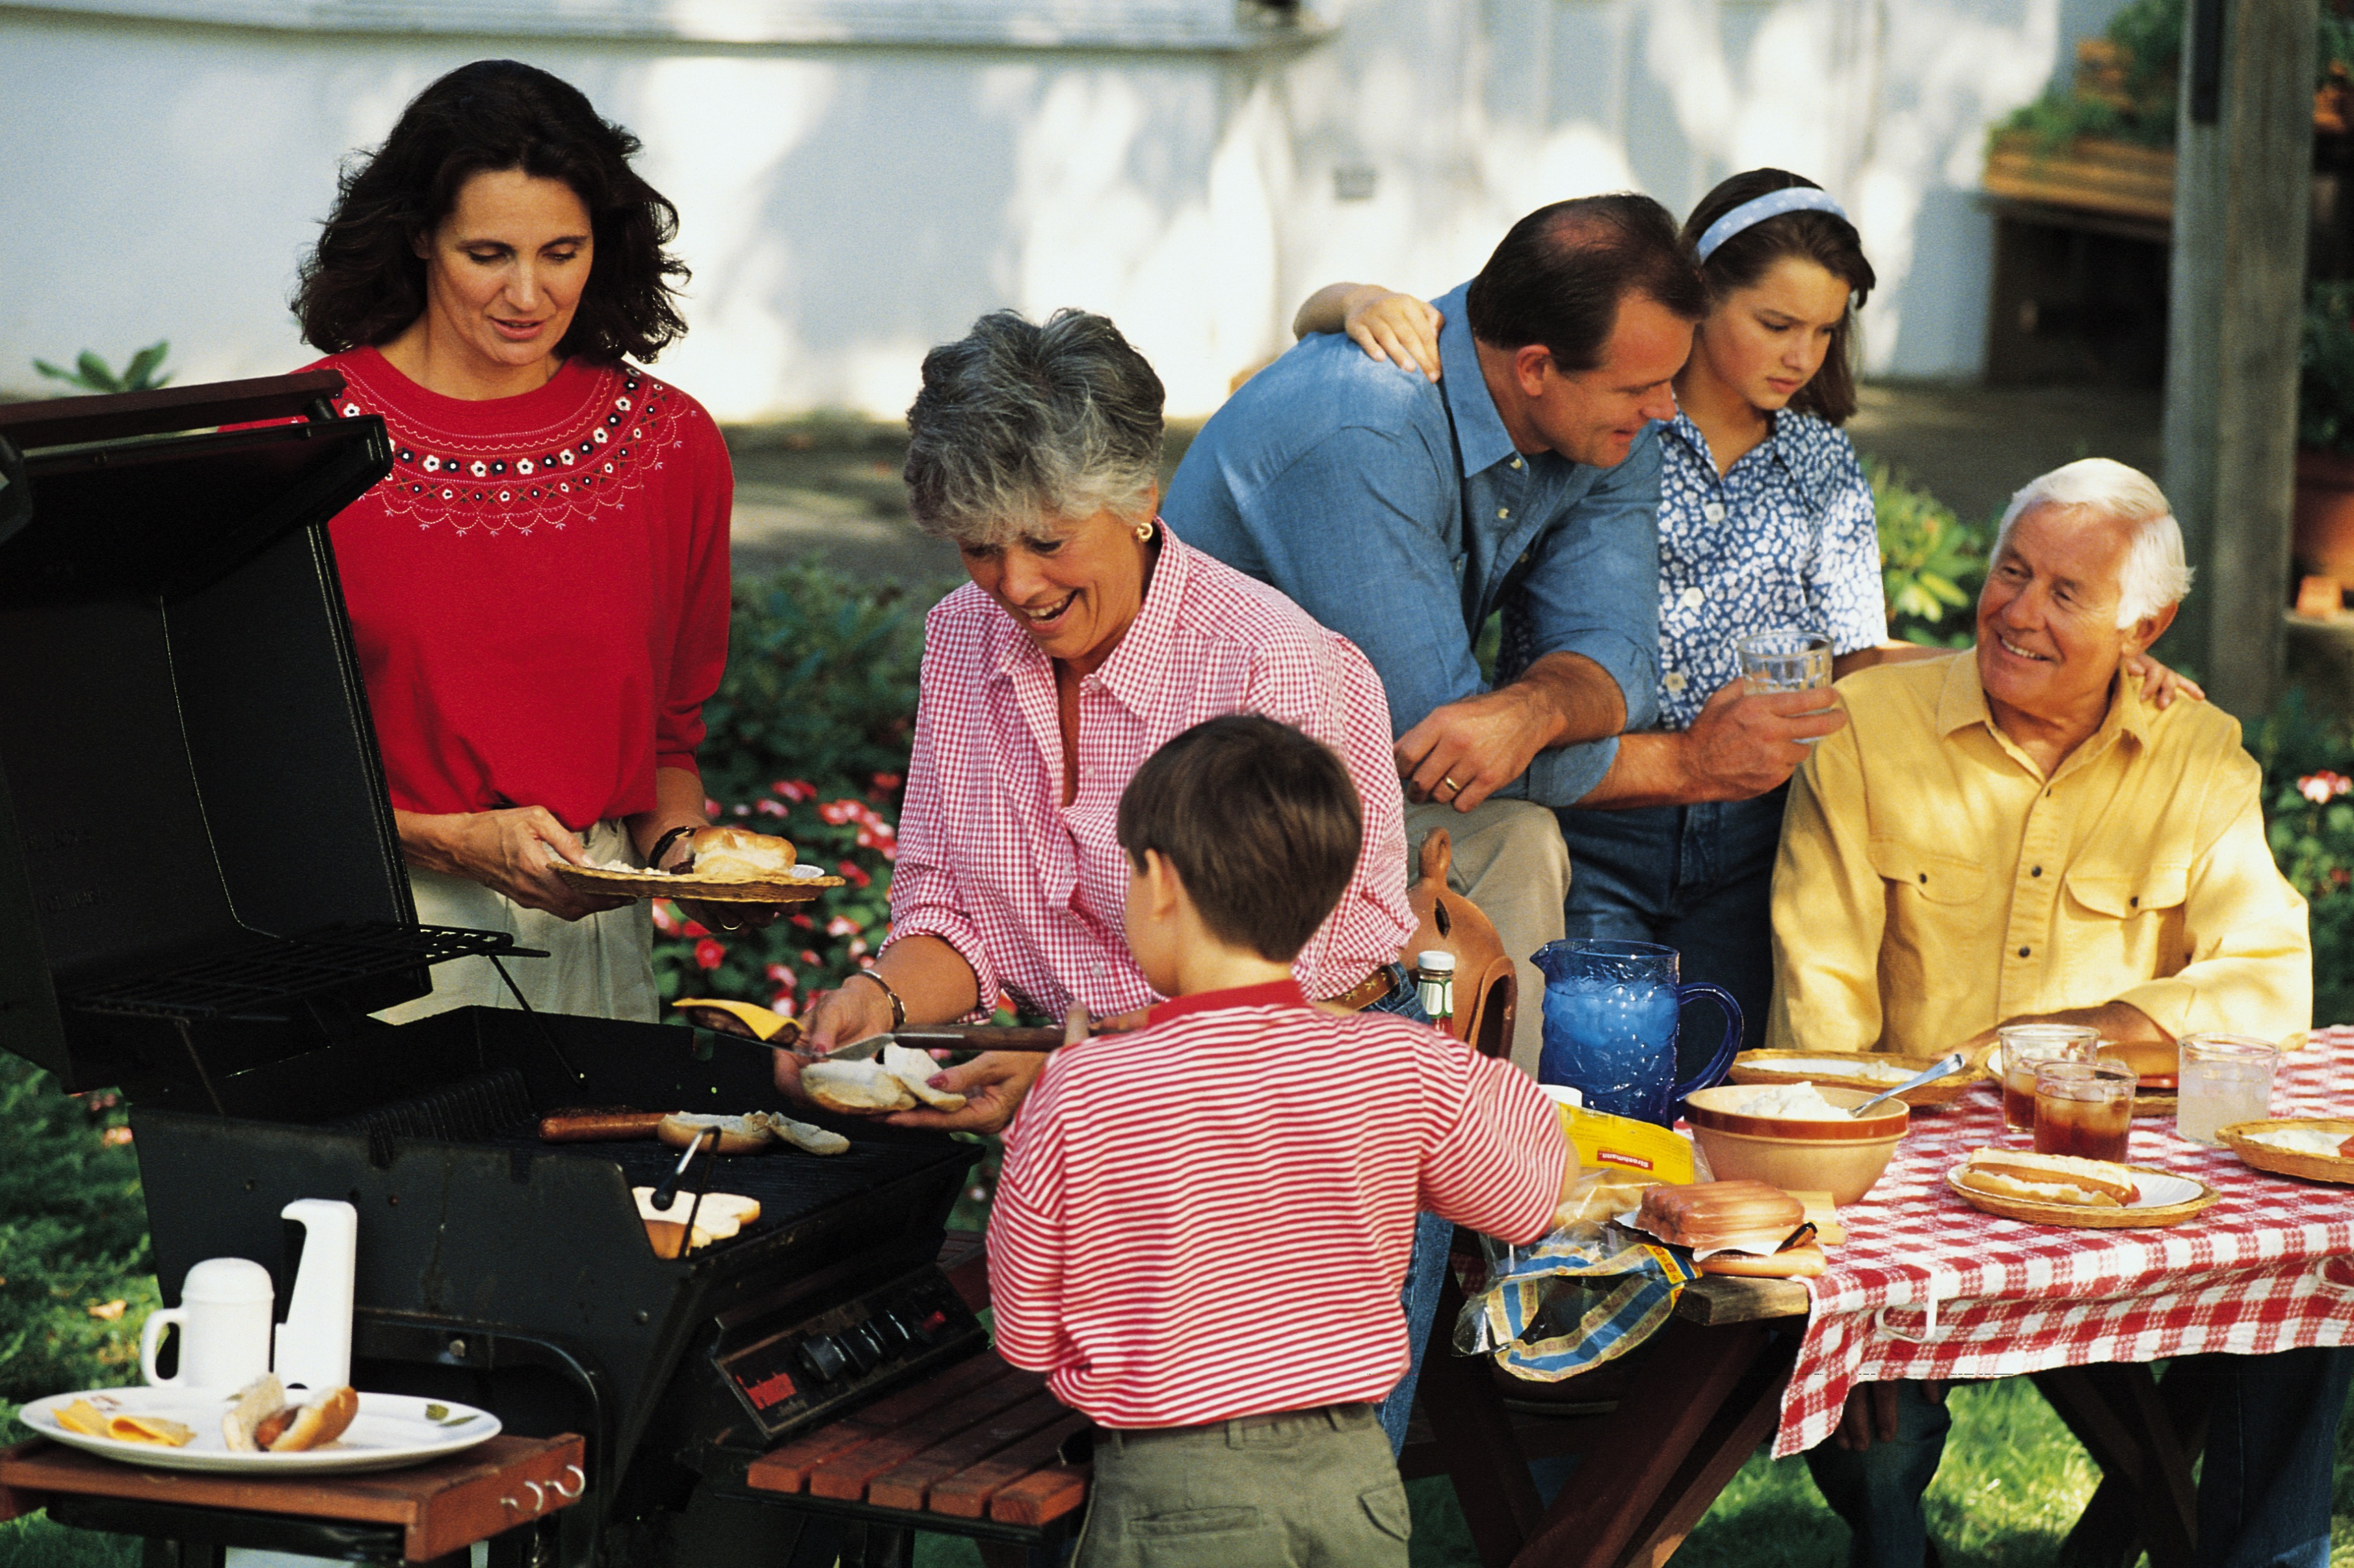
PART TWO | Relationships

B

