10
2A | 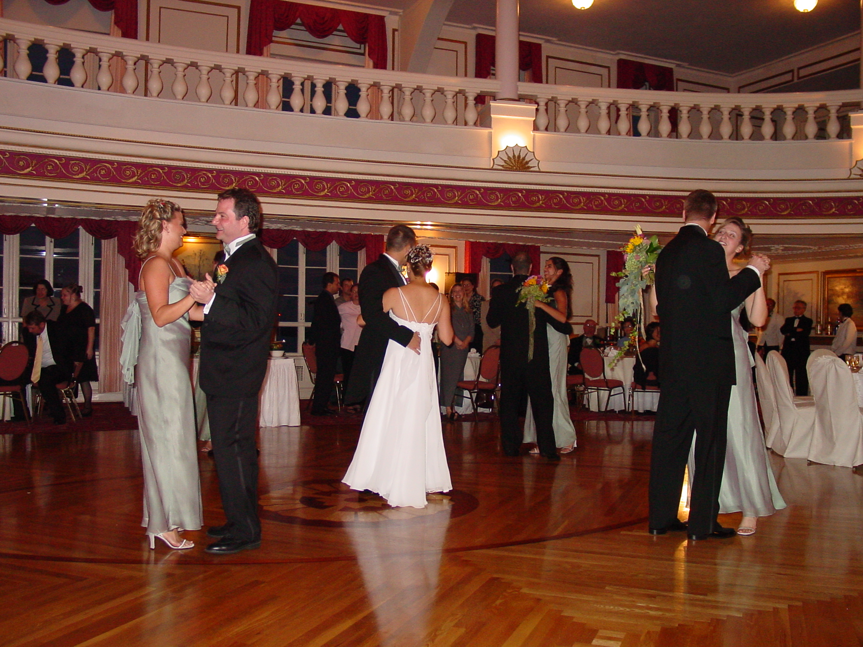
The following ideas may help you:

- Place
- People (appearance, age, etc.)
- Clothes
- Activities
- Atmosphere
- Other
2B | 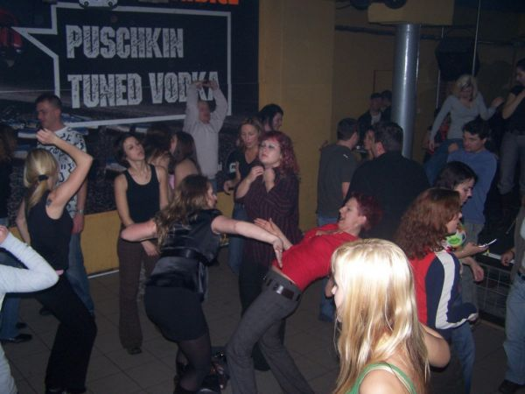
PART TWO | Social events - dancing

B

