9
2A | 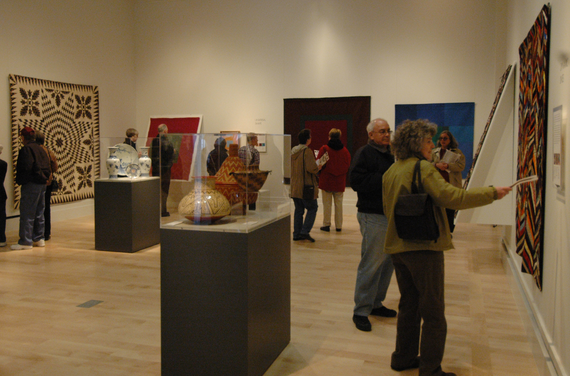
The following ideas may help you:

- Cultural event
- Place
- People
- Things you see
- Atmosphere
- Other
2B | 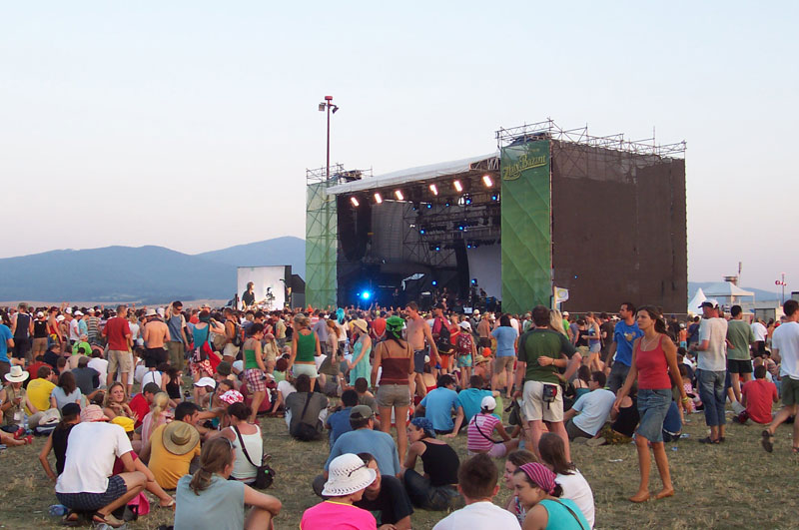
PART TWO | Cultural event

B

