Hello. (Sit down, please. Would you tell me your task sheet number so I can check it, please?)
8
TOPIC: Free time and entertainment – sport
INTRODUCTION | 0,5 min.

First, could you briefly introduce yourself to the committee?

Thank you.
Now, let’s go to Part One.
I am going to ask you some questions about the topic Sport. If possible, give detailed answers. If you don’t understand a question, please ask me to repeat it.
PART ONE (3–5 Qs) | Sport | 2,5 min.
Are you ready?

- Is sport important for you? Why?/Why not?
- When you were a child, which sports or games did you use to do with your peers/friends? Tell me about it.
- Is there a sport you would like to try one day? Why?/Why not?
- In your opinion, which sports should everyone learn when young? Why?
- Do you think sportspeople are good idols/role models for young people? Why?/Why not?
- What are the advantages and disadvantages of team sports? Why?

Thank you. Now, let’s go to Part Two.
Look at pictures 2A and 2B on the separate handout and compare and contrast them in detail.
PART TWO | Sport | 4 min.
Task One | 2,5 min.
Are you ready?
Thank you. Now, let’s go to Task Two.
- Place  - People (age, appearance, etc.)  - Activities  - Clothes/Equipment  - Atmosphere  - Other | - What are the advantages and disadvantages of these sports?  - Which sport, do you think, is more demanding in terms of time/energy/money?  - Which sport is easier to practise/more competitive/more relaxing? Why?  - Which of these two sports do you prefer? Why?

Read aloud the statement and express and justify your opinion on it.
Task Two | 1,5 min.
Every country and all its inhabitants would like to host the Olympic Games. | - Do you agree or disagree with the statement? Why?  - Present an example and/or talk about your own experience.
B

Thank you. Now, let’s go to Part Three.

Now, please take the student's task sheet for part three.
PART THREE |  | 5 min.
Now we are going to talk together using pictures 4A–4C. Imagine the following situation:
PART FOUR | Sport | 3 min.
We are friends. You would like to start doing a sport regularly and you would like me to join you. However, I am not much into sport. First, choose one sport and then try to convince me to join you. You should start the conversation.
Are you ready?
4A | 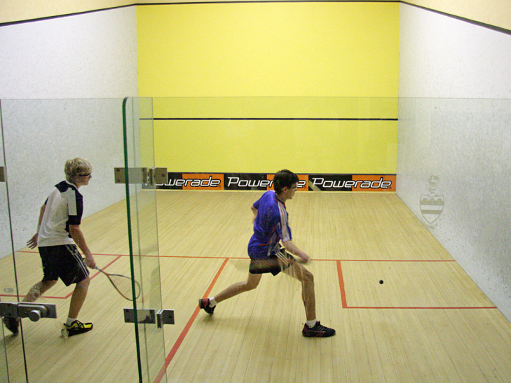 | 4B | 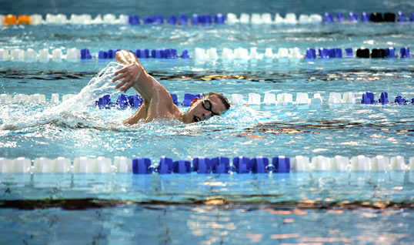
4C | 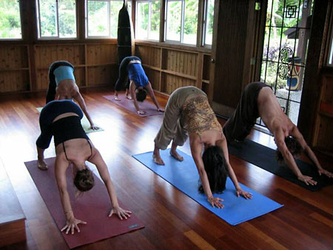 | 4D | Other?
- Health benefits  - Meeting new friends  - Spending time together  - Having fun  - Sport suitable for everybody  - Other | - I do not like doing sports. / I hate sweating. / I can’t swim.  - I work long hours. I do not have time for fitness.  - I feel uncomfortable in a fitness centre.  - I have problems with my knees. I cannot jump or run.  - I do not know what to wear.  - It is difficult to learn, isn’t it?  - So what have we agreed on?
B

Thank you. That is the end of the examination.

