The examiner is going to ask you some questions. Please answer the questions in as much detail as possible. If you don’t understand a question, please ask the examiner to repeat it.
8
TOPIC: Free time and entertainment – sport
PART ONE (2,5 min.) | You and sports
Part Two consists of two tasks.
PART TWO (4 min.) | Sport
Take the separate handout with pictures 2A and 2B. The pictures show two different sports.
Task One | 2,5 min.
Look at the pictures and compare and contrast them in detail.
The following ideas may help you:

- Place
- People (age, appearance, etc.)
- Activities
- Clothes/Equipment
- Atmosphere
- Other

Task Two | 1,5 min.
Prepare to express and justify your opinion on the following statement.

Every country and all its inhabitants would like to host the Olympic Games.
The following ideas may help you:
B

- Do you agree or disagree with the statement? Why?
- Present an example and/or talk about your own experience.
Take the student's task sheet for PART THREE.
In Part Four of the exam, you and the examiner are going to talk together (using pictures 4A – 4C). Imagine the following situation:
PART THREE (5 min.)
PART FOUR (3 min.) | Sport
You would like to start doing a sport regularly and you would like your friend to join you. However, he/she is not much into sport. First, choose a kind of sport and then try to convince him/her to join you. The examiner will play the role of your friend. You should start the dialogue.

The following ideas may help you:
B

- Health benefits
- Meeting new friends
- Spending time together
- Having fun
- Sport suitable for everybody
- Other

The following pictures may help you:

4A | 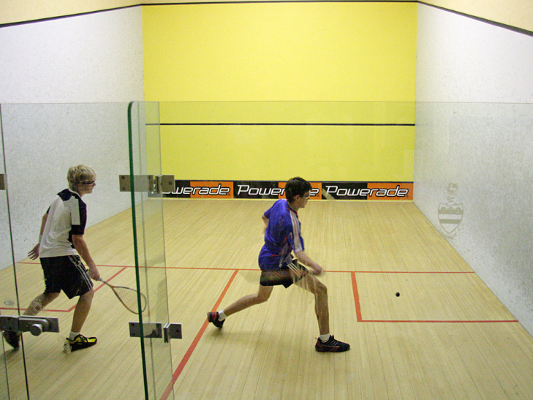 | 4B | 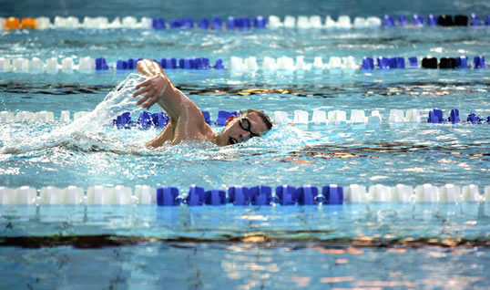
4C | 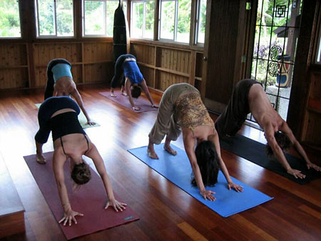 | 4D | Other?

