8
2A | 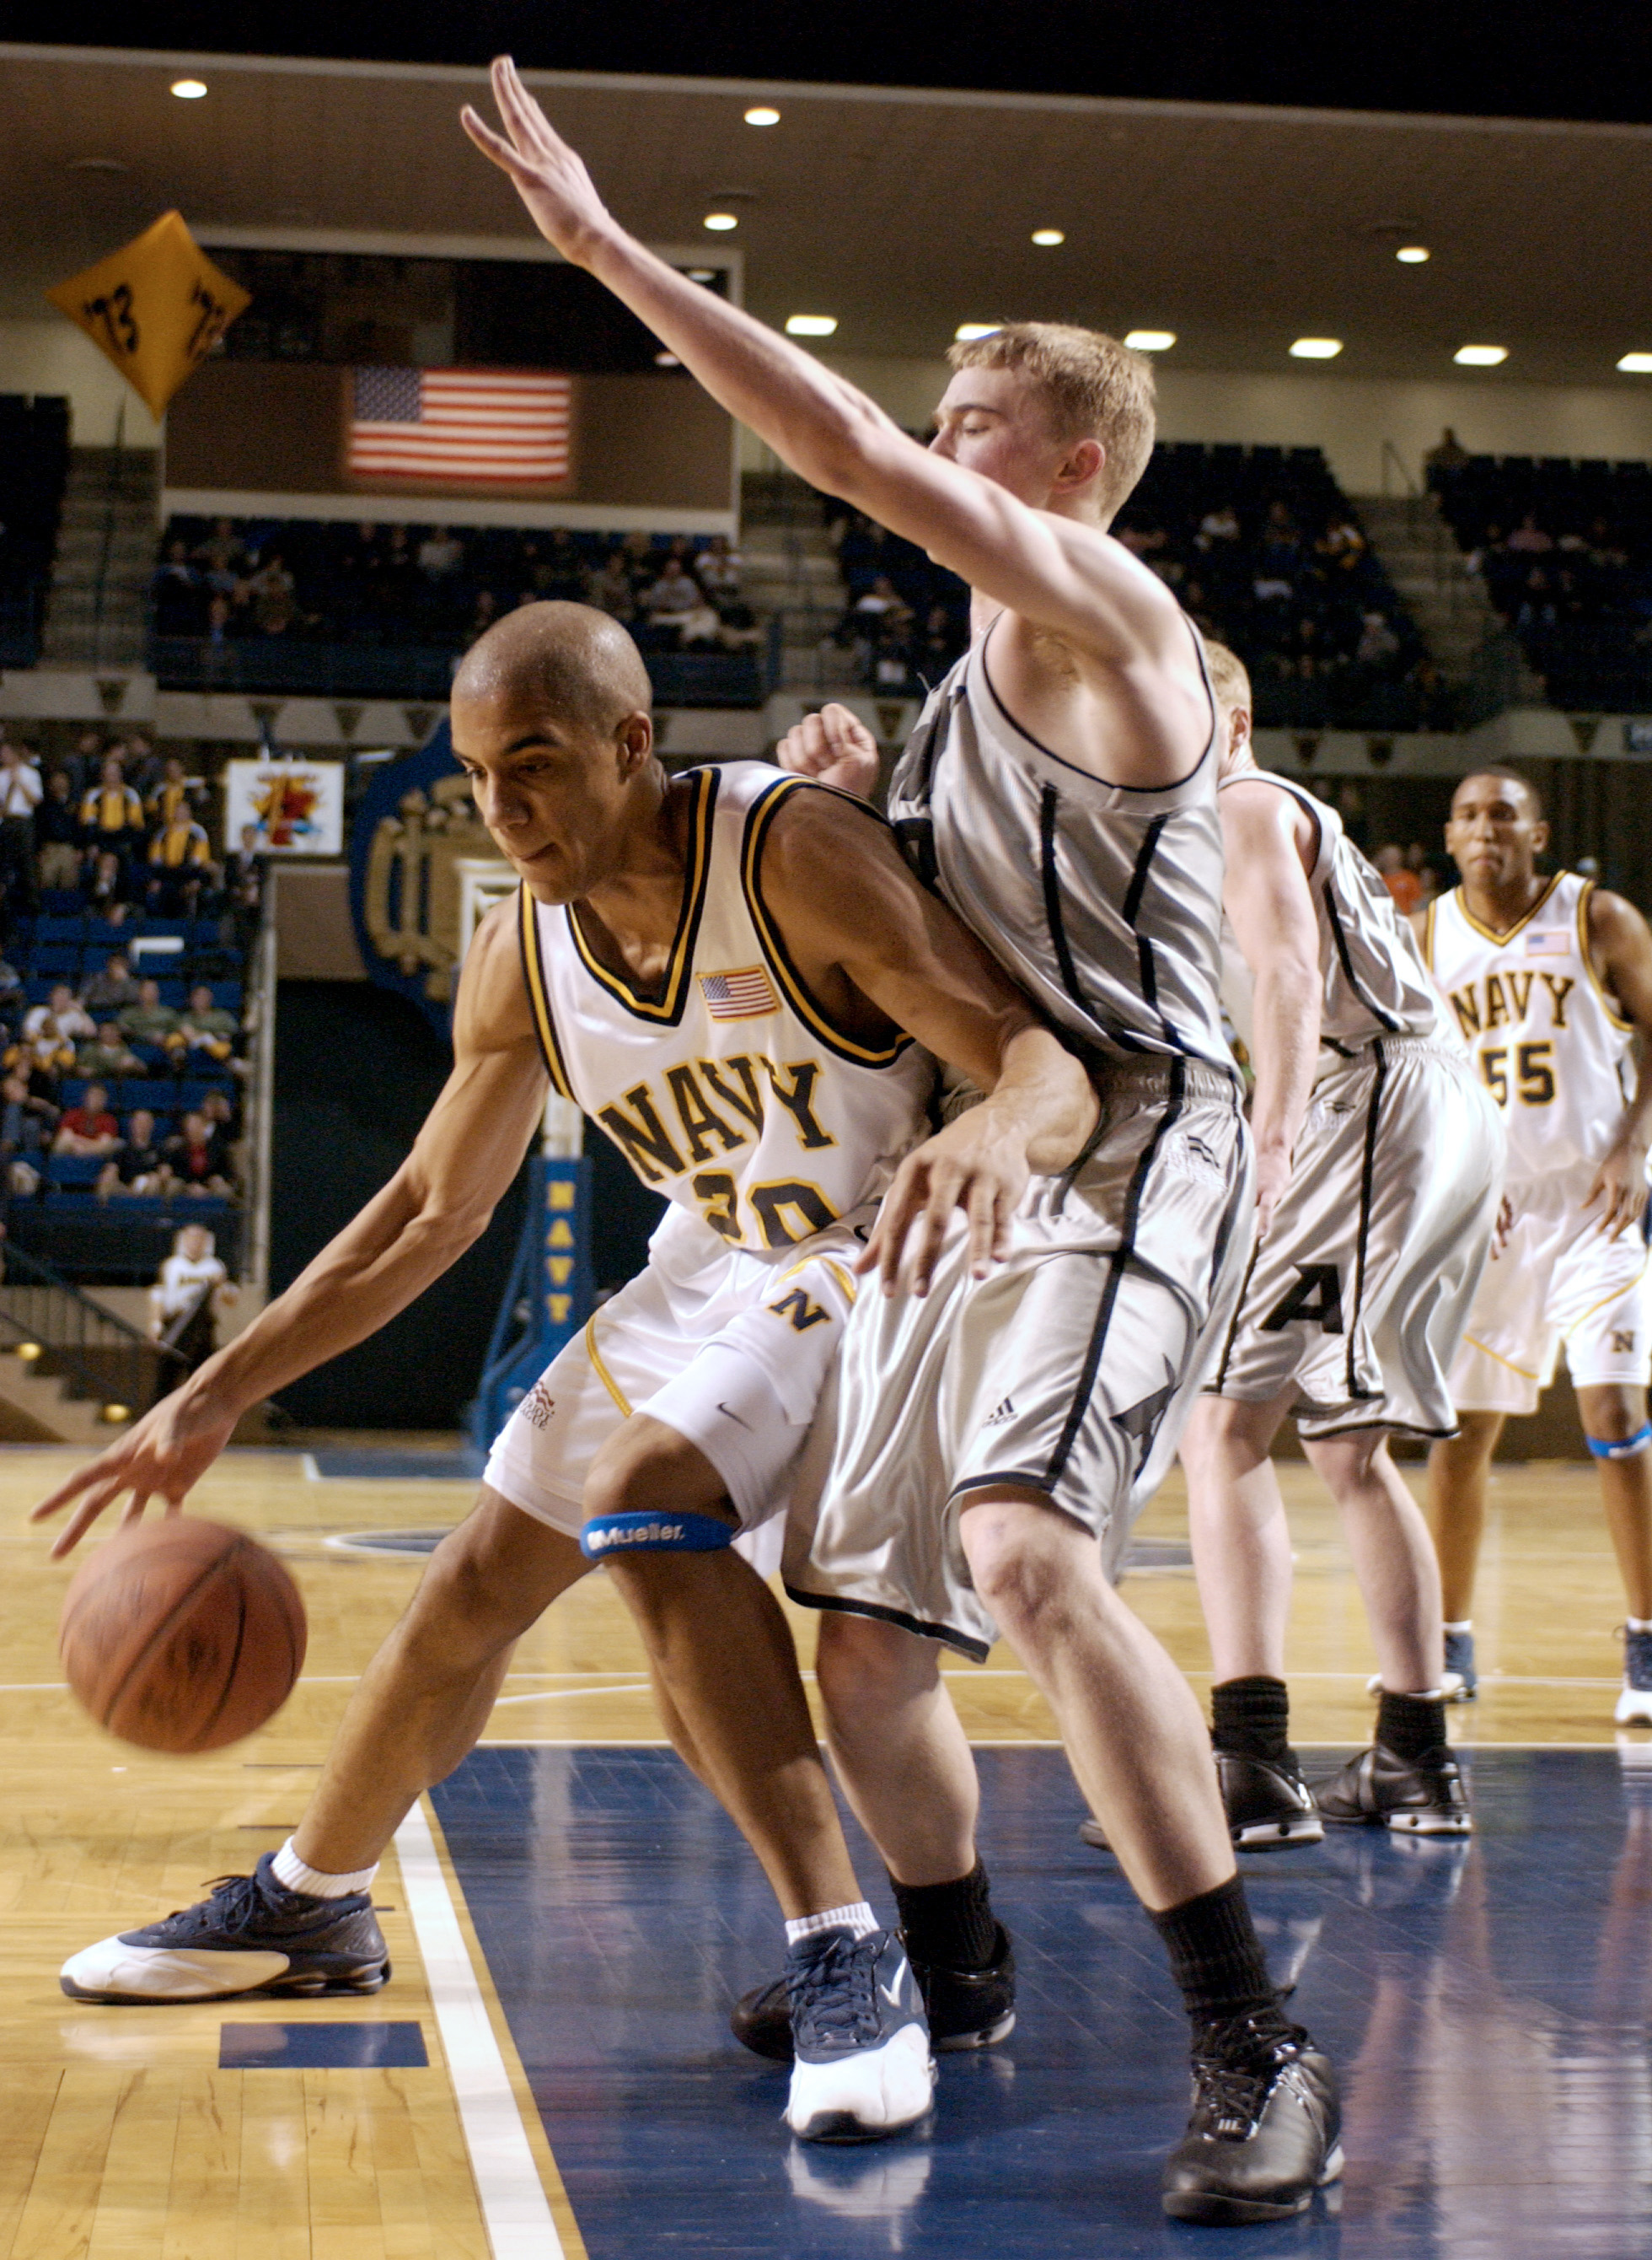
The following ideas may help you:

- Place
- People (age, appearance)
- Activities
- Clothes/Equipment
- Atmosphere
- Other
2B | 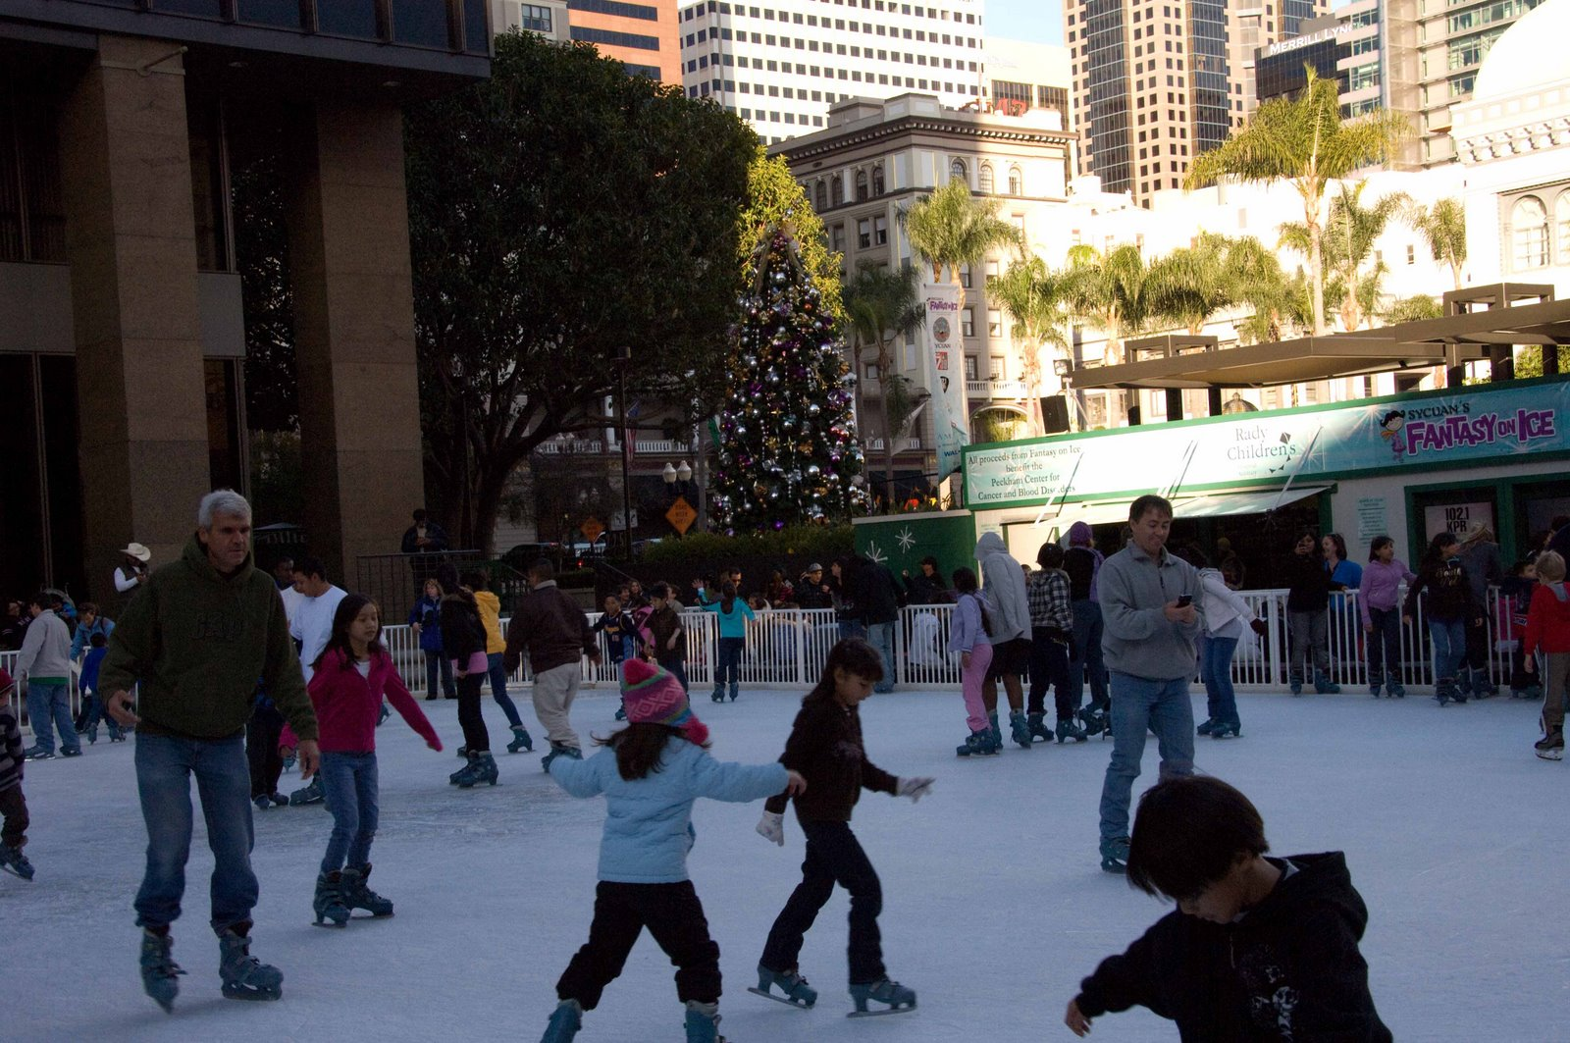
PART TWO | Sport

B

