7
2A | 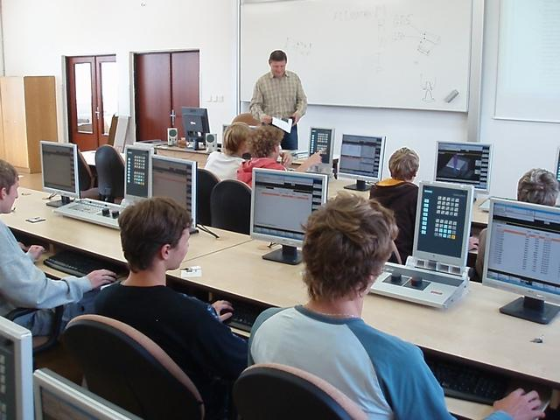
The following ideas may help you:

- Place
- People
- Type of school
- Equipment
- Atmosphere
- Other
2B | 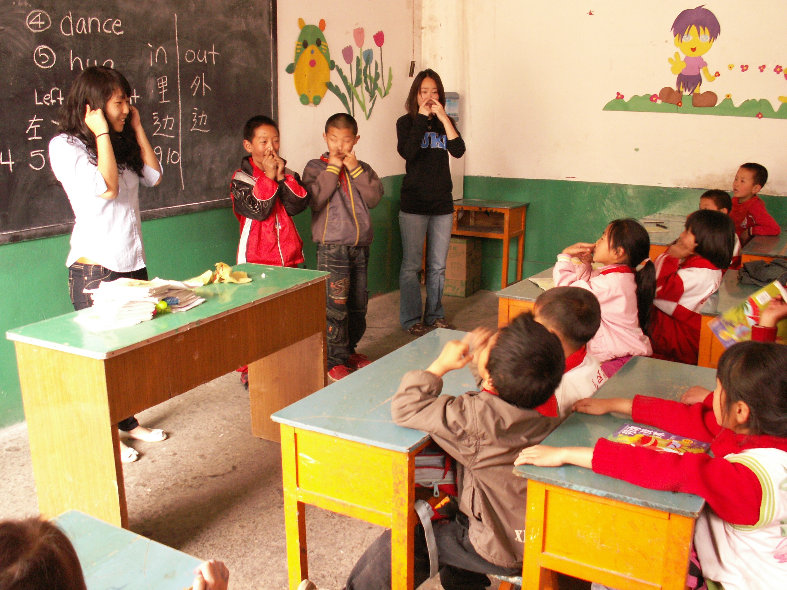
PART TWO | Schools

B

