6
2A | 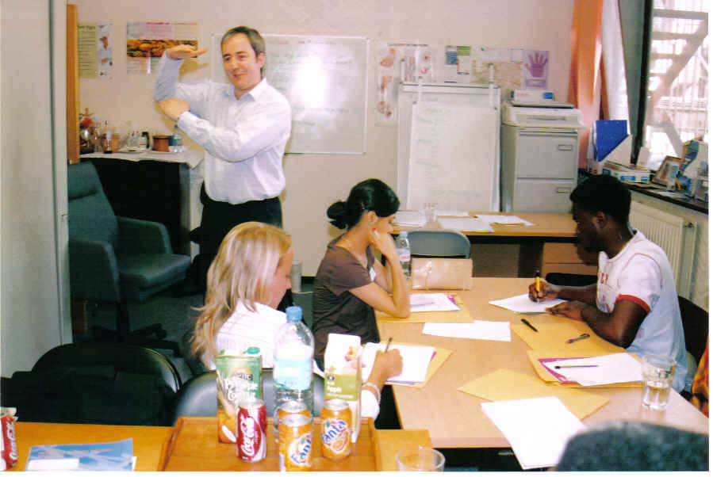
The following ideas may help you:

- Place
- People
- Equipment
- Kind of lesson
- Atmosphere
- Other
2B | 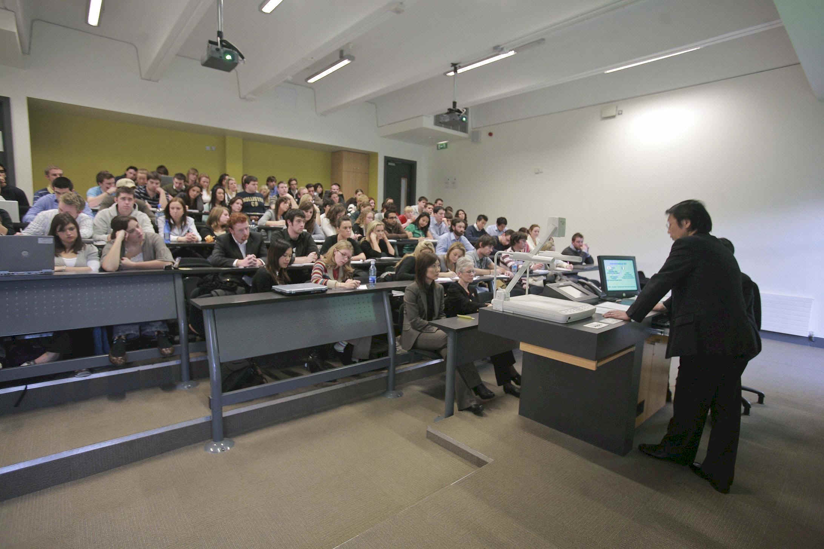
PART TWO | Education

B

