5
2A | 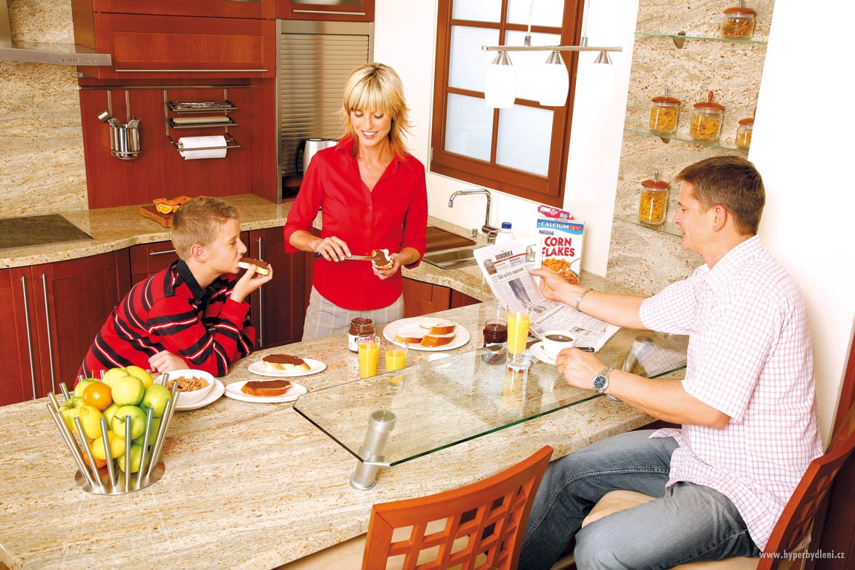
The following ideas may help you:

- Place
- Time of the day
- People
- Activities
- Atmosphere
- Other
2B | 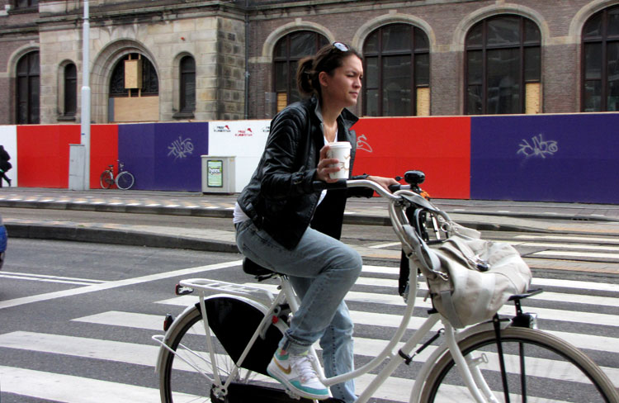
PART TWO | Daily routine

B

