3
2A | 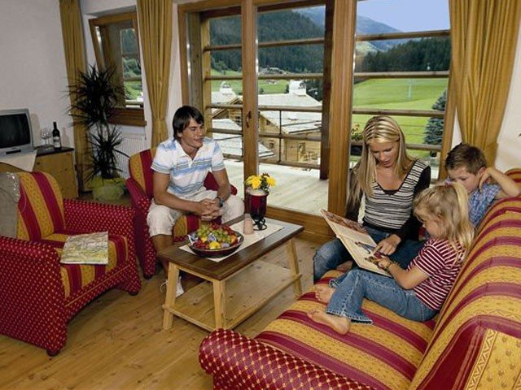
The following ideas may help you:

- Place
- People
- Activities
- Furniture/Equipment
- Advantages/Disadvantages of living there
- Other
2B | 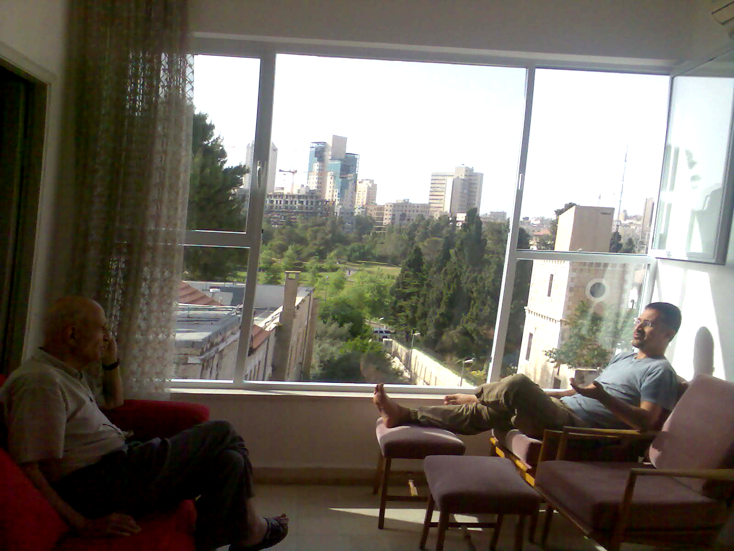
PART TWO | Housing and living

B

