1
2A | 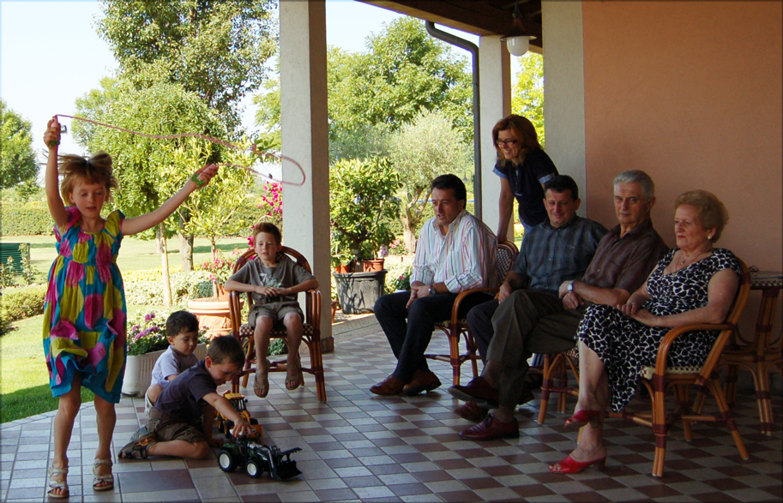
The following ideas may help you:

- Place
- People
- Activities
- Furniture/Equipment
- Atmosphere
- Other
2B | 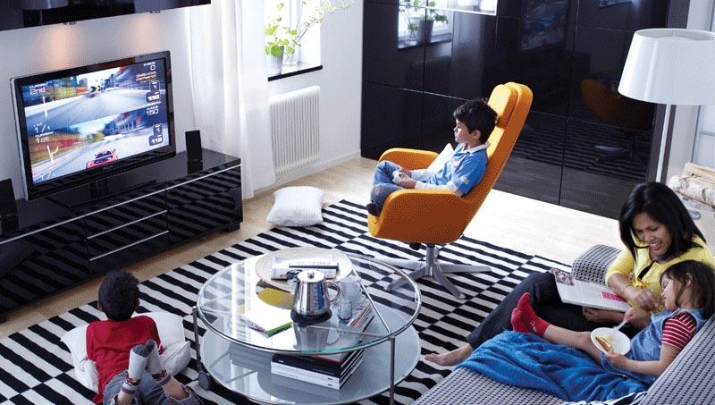
PART TWO | Family

B

