25
PART TWO | Environment
2A | 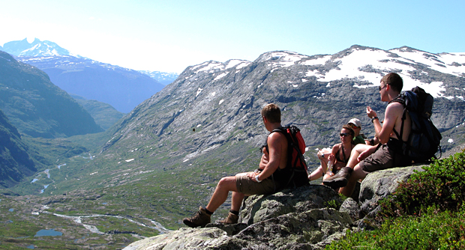
The following ideas may help you:

- Place/Location
- People
- Activities
- Weather
- Environment
- Other
2B | 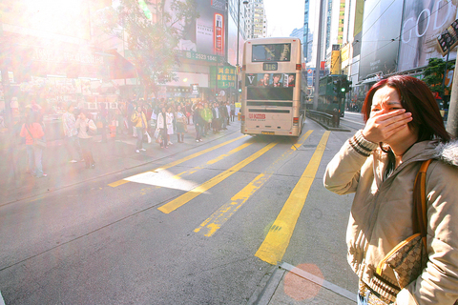

A

