Hello. (Sit down, please. Would you tell me your task sheet number so I can check it, please?)
21
TOPIC: Society and mass media
INTRODUCTION | 0,5 min.

First, could you briefly introduce yourself to the committee?

Thank you. Now, let’s go to Part One.
I am going to ask you some questions about the topic Mass media. If possible, give detailed answers. If you don’t understand a question, please ask me to repeat it.
PART ONE (3–5 Qs) | Mass media | 2,5 min.
Are you ready?

- Do you watch news on TV? Tell me more about it./Why not?
- Where do you find information when you need it? Why?/Tell me more about it.
- Have you ever read a magazine in English? Tell me more about it./Why not?
- Which modern technology could you not live without? Why?
- How did the people in the past spend their evenings without a TV? What do you think?
- Should TV commercials for cigarettes and alcohol be banned? Why?/Why not?

Thank you. Now, let’s go to Part Two.
Look at pictures 2A and 2B on the separate handout.
PART TWO | Mass media | 4 min.
Which picture would you like to talk about? … Describe it, please. Are you ready?
Task One | 1,5 min.
Thank you. Now, let’s go to Task Two.
- Place  - People (age, appearance, clothes)  - Activities  - Equipment  - Atmosphere  - Other | - What time of the day is it? Why do you think so?  - How do the people feel? Why do you think so?  - How do you like the place? Would you change anything about it?  - Would you like to be the person in the picture? Why?/Why not?
Have a look at both pictures once more. Now, I would like you to compare them.
Task Two | 1 min.
Are you ready?
Thank you. Now, let’s go to Task Three.
- Place  - People (age, appearance, clothes)  - Activities  - Equipment  - Atmosphere  - Other | - Who is more relaxed? Why?  - What are the advantages/disadvantages of working for a TV station/watching TV at home?  - Which situation would you prefer? Why?
Now, tell me about the type(s) of mass media you use in your daily life.
Task Three | 1,5 min.

- Which media do you use every day?
- Why do you use them?
- Which media can you not live without? Why?

Thank you. Now, let’s go to Part Three.
A

Now, please take the student's task sheet for part three.
PART THREE |  | 5 min.
Now we are going to talk together using pictures 4A–4C. Imagine the following situation:
PART FOUR | Magazine subscription as a present | 3 min.
We are friends and we have a common friend who likes reading magazines. We would like to give him or her a magazine subscription as a birthday present. First, we should agree on a magazine and then talk about the details of ordering it. I will start the dialogue. Are you ready?
monthly, £42/per year
- Friend’s interests  - Price  - How to order?  - For how long?  - How to give it to him/her?  - Other | - I have thought about the birthday present for John/Lucy, and how about giving him/her a subscription to a magazine? What do you think?  - What do you think he/she would like to read? Why?  - How much can we spend? / Isn’t it too expensive?  - How will we order it?/per phone/Internet  - Should we order it for the whole year/six months?  - Do you have any idea how we can wrap/present it? We will only have a letter from the company.  - So what have we agreed on?
A
4A |  | 4B | 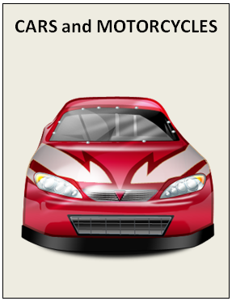
 | monthly, £36/per year |  | monthly, £66/per year
4C |  | 4D | OTHER?

monthly, £42/per year

Thank you very much. That is the end of the examination.

