21
TOPIC: Society and mass media
PART ONE (2,5 min.) | Mass media
The examiner is going to ask you some questions. Please answer the questions in as much detail as possible. If you don’t understand a question, please ask the examiner to repeat it.
PART TWO (4 min.) | Mass media
Part Two consists of three tasks. Take the separate handout with pictures 2A and 2B. The pictures show two different views of TV.
Task One | 1,5 min.
Look at pictures 2A and 2B on the separate handout. Choose one of the pictures and describe it.
The following ideas may help you:

- Place
- People (age, appearance, clothes)
- Activities
- Equipment
- Atmosphere
- Other
Task Two | 1 min.
Look at both pictures once more and compare them (what is similar/the same/different?).
The following ideas may help you:

- Place
- People (age, appearance, clothes)
- Activities
- Equipment
- Atmosphere
- Other

Task Three | 1,5 min.
Talk about the type(s) of mass media you use in your daily life.
A

PART THREE (5 min.)
Take the student's task sheet for PART THREE.
PART FOUR (3 min.) | Magazine subscription as a present
In Part Four of the exam, you and the examiner are going to talk together. Imagine the following situation:
You and your English speaking friend have a common friend who likes reading magazines. It’s his/her birthday soon and you would like to give him/her a subscription to a magazine as a present. First, you should agree on a magazine and then talk about the details of ordering it. The examiner will play the role of your English speaking friend and will start the dialogue.

The following ideas may help you:
A

- Friend’s interests
- Price
- How to order?
- For how long?
- How to give it to him/her?
- Other

The following pictures may help you:

4A |  | 4B | 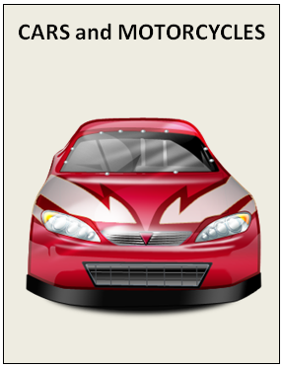
 | monthly, £36/per year |  | monthly, £66/per year
4C | 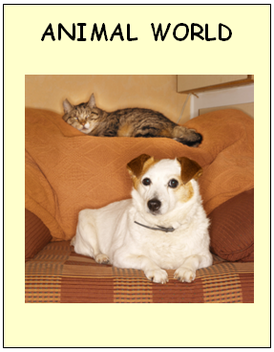 | 4D | OTHER?
monthly, £42/per year

