20
PART TWO | Services – accommodation
2A | 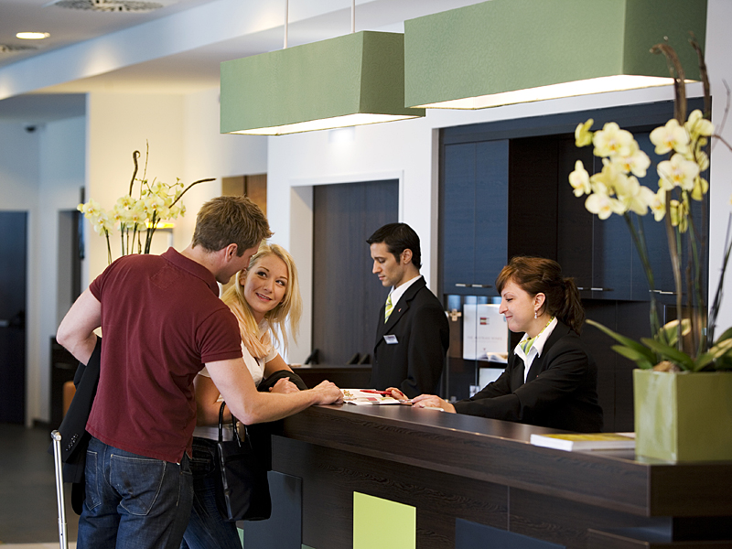
The following ideas may help you:

- Place
- People (appearance, clothes)
- Activities
- Comfort
- Atmosphere
- Other
2B | 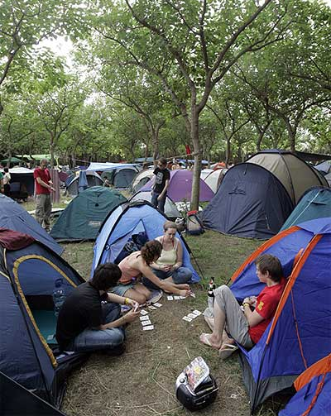

A

