19
PART TWO | Communication
2A | 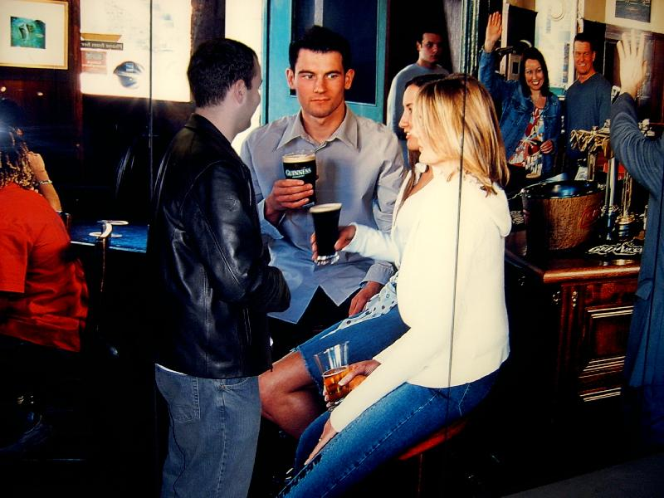
The following ideas may help you:

- Place
- People (age, appearance, clothes)
- Activities
- Means of communication
- Atmosphere
- Other
2B | 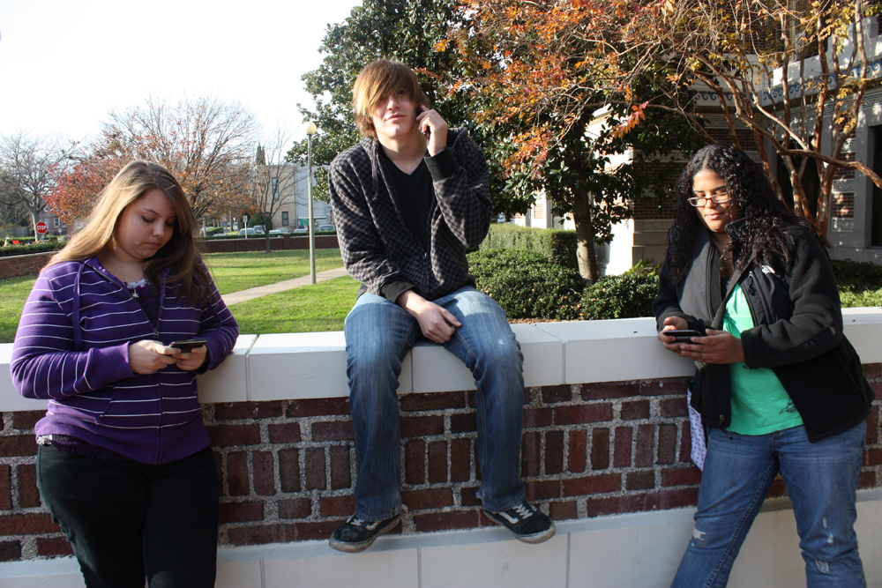

A

