18
PART TWO | Jobs
2A | 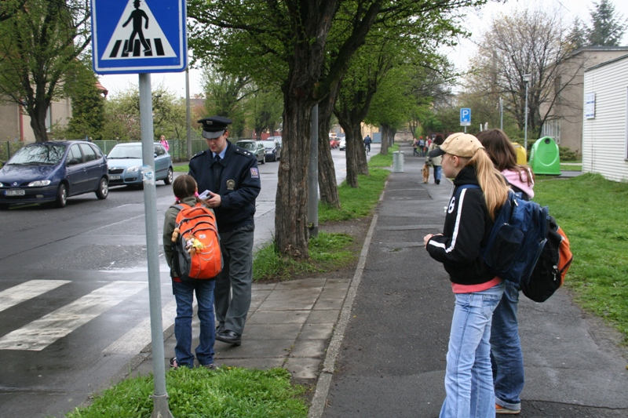
The following ideas may help you:

- Place
- People (appearance, clothes, age)
- Activities
- Job
- Things (What? Where?)
- Other
2B | 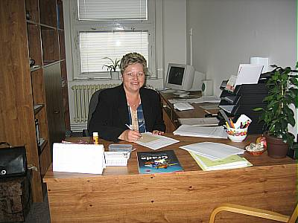

A

