17
PART TWO | Shopping
2A | 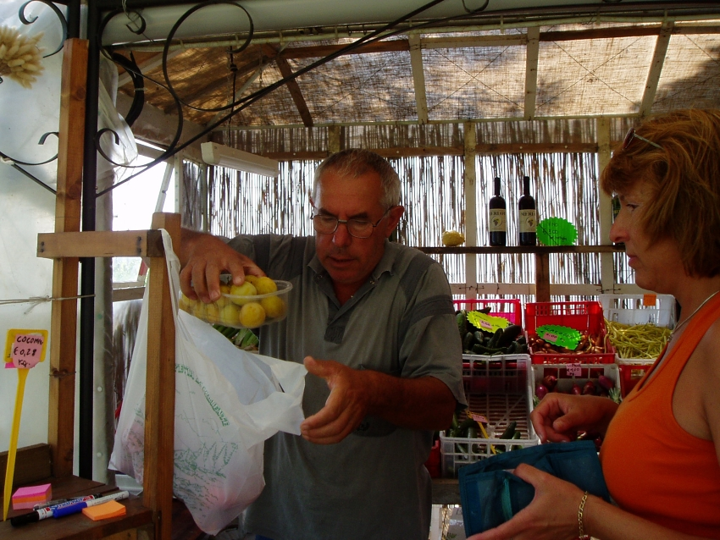
The following ideas may help you:

- Place/Location
- People (age, appearance, etc.)
- Activities
- Shop/Products
- Atmosphere
- Other
2B | 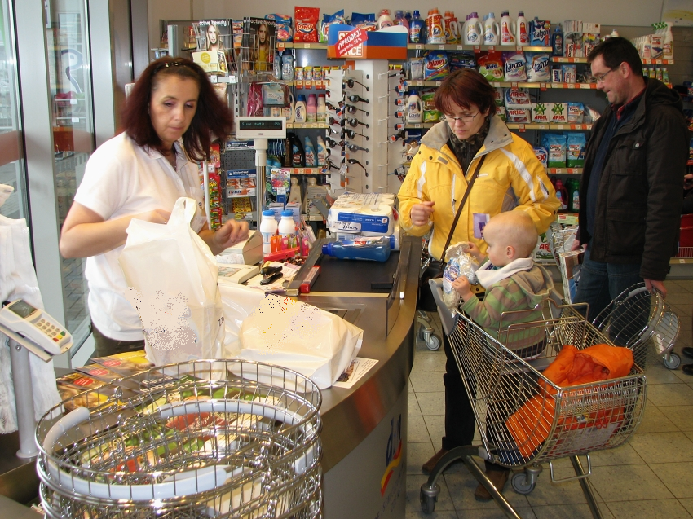

A

