16
PART TWO | Food and drink
2A | 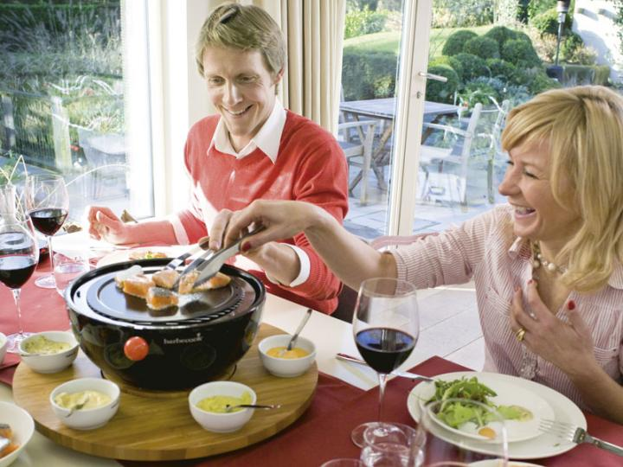
The following ideas may help you:

- Place
- People (appearance, clothes, etc.)
- Food and drinks
- Price/Service
- Atmosphere
- Other
2B | 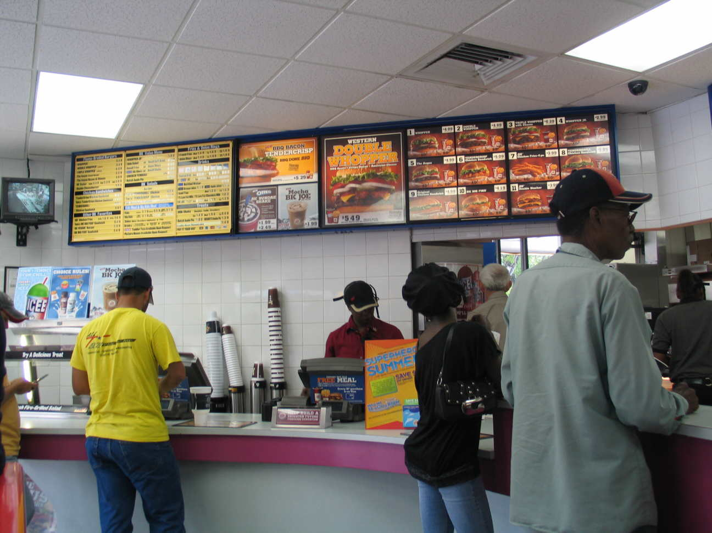

A

