15
PART TWO | Food and drinks
2A | 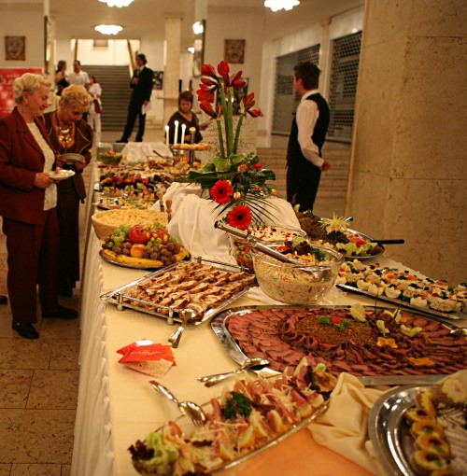
The following ideas may help you:

- Place
- People (clothing, age etc.)
- Activities
- Food and drinks
- Atmosphere
- Other
2B | 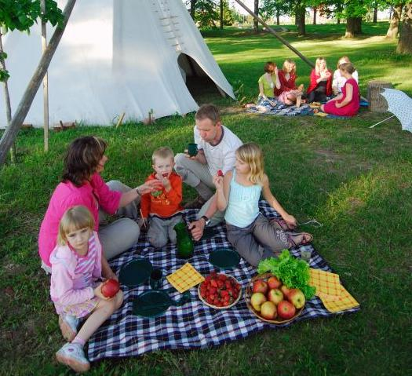

A

