14
2A | 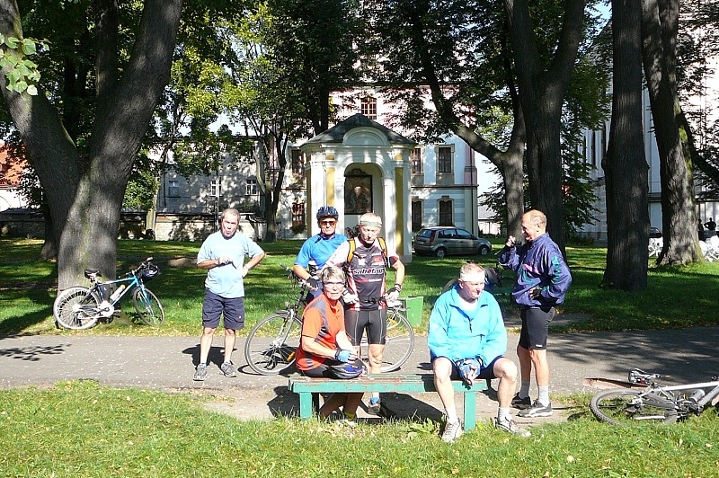
The following ideas may help you:

- Place
- People (age, clothes)
- Activities
- Lifestyle
- Atmosphere
- Other
2B | 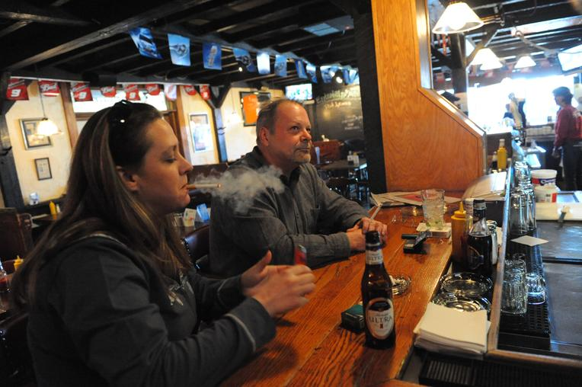
PART TWO | Healthy lifestyle

A

