13
2A | 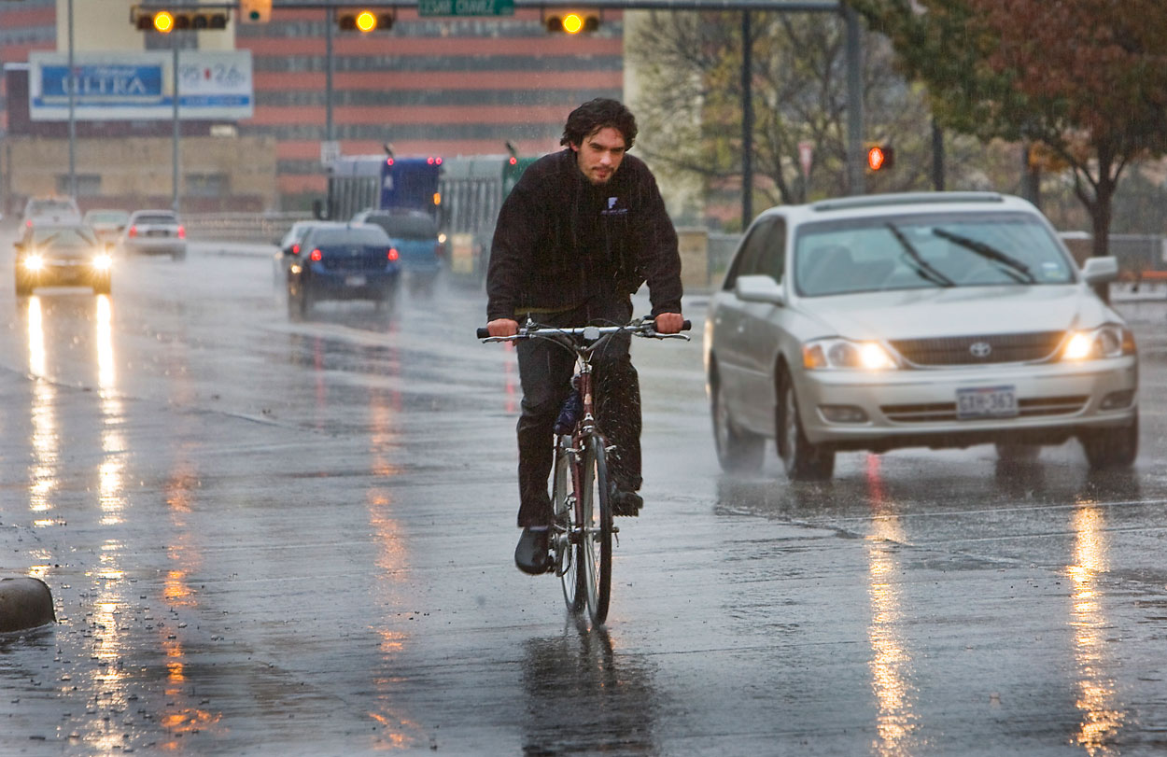
The following ideas may help you:

- Place
- People (appearance, clothes, etc.)
- Activities
- Weather/Season
- Means of transport
- Other
2B | 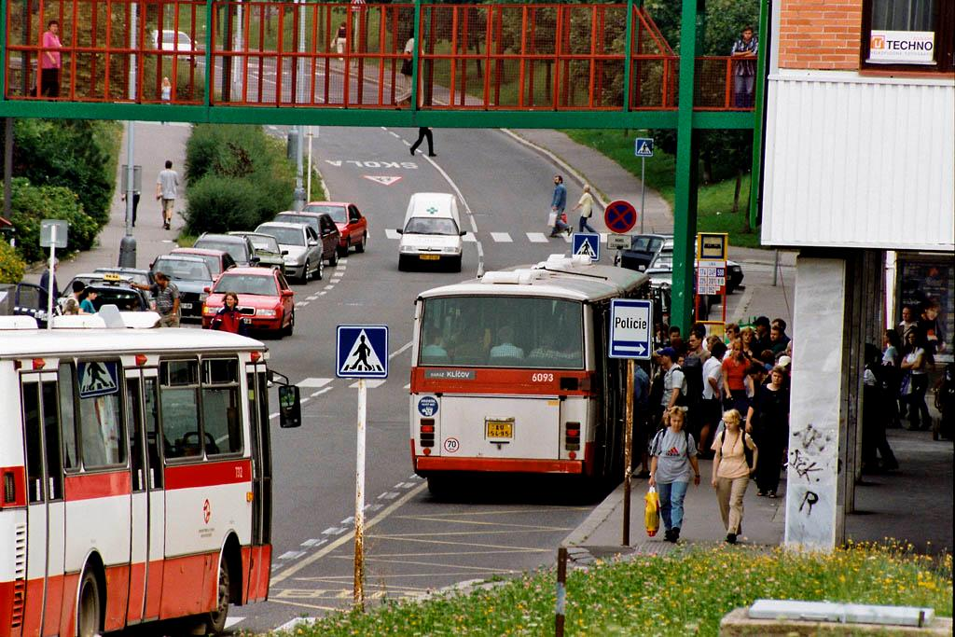
PART TWO | Means of transport

A

