Hello. (Sit down, please. Would you tell me your task sheet number so I can check it, please?)
12
TOPIC: Travelling – holidays, trips
INTRODUCTION | 0,5 min.

First, could you briefly introduce yourself to the committee?

Thank you. Now, let’s go to Part One.
I am going to ask you some questions about the topic Free time – travelling. If possible, give detailed answers. If you don’t understand a question, please ask me to repeat it.
PART ONE (3–5 Qs) | Free time - holidays | 2,5 min.
Are you ready?

- How do you usually spend your winter holidays?
- Do you prefer going on holidays with your friends or your family? Why?
- How did you spend your holidays when you were a small child?
- What are the advantages/disadvantages of package holidays/travelling on your own? Why?
- Should students have less free days/holidays than they have now? Why? Why not?
- If you had enough money, which foreign country would you like to visit? Why?

Thank you. Now, let’s go to Part Two.
Look at pictures 2A and 2B on the separate handout.
PART TWO | Holidays | 4 min.
Which picture would you like to talk about? … Describe it, please. Are you ready?
Task One | 1,5 min.
Thank you. Now, let’s go to Task Two.
- Place  - People (clothes, activities, etc.)  - Weather/Season  - Type of holiday  - Atmosphere  - Other | - What things/objects can you see in the picture?  - Can you describe a person in detail?  - Would you like to spend your holiday this way? Why?/Why not?
Have a look at both pictures once more. Now, I would like you to compare them.
Task Two | 1 min.
Are you ready?
Thank you. Now, let’s go to Task Three.
- Place  - People  - Weather/Season  - Type of holiday  - Atmosphere  - Other | - Which of the two types of holiday would you prefer? Why?  - Which of them is more relaxing/active?  - Which holiday is more interesting? Why?
Now, tell me about your dream holiday.
Task Three | 1,5 min.

- Who would you like to spend it with? Why?
- Where would you like to go? Why?
- What activities would you like to do?

Thank you. Now, let’s go to Part Three.
A

Now, please take the student's task sheet for part three.
PART THREE |  | 5 min.
Now we are going to talk together using pictures 4A–4C. Imagine the following situation:
PART FOUR | Free time – travelling | 3 min.
We are friends and we would like to spend the next holidays together. First, we should choose a destination and then we should talk about other details of the holidays. I will start the conversation. Are you ready?
4A | 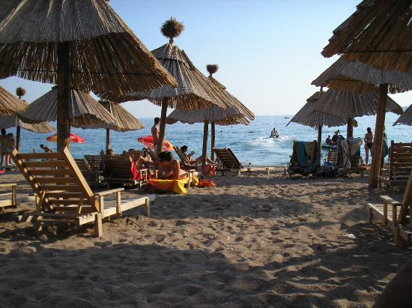 | 4B | 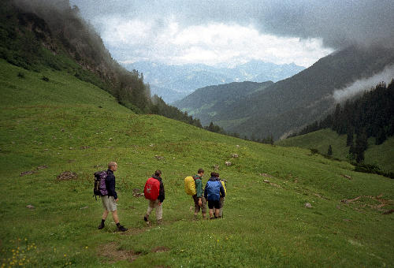
4C | 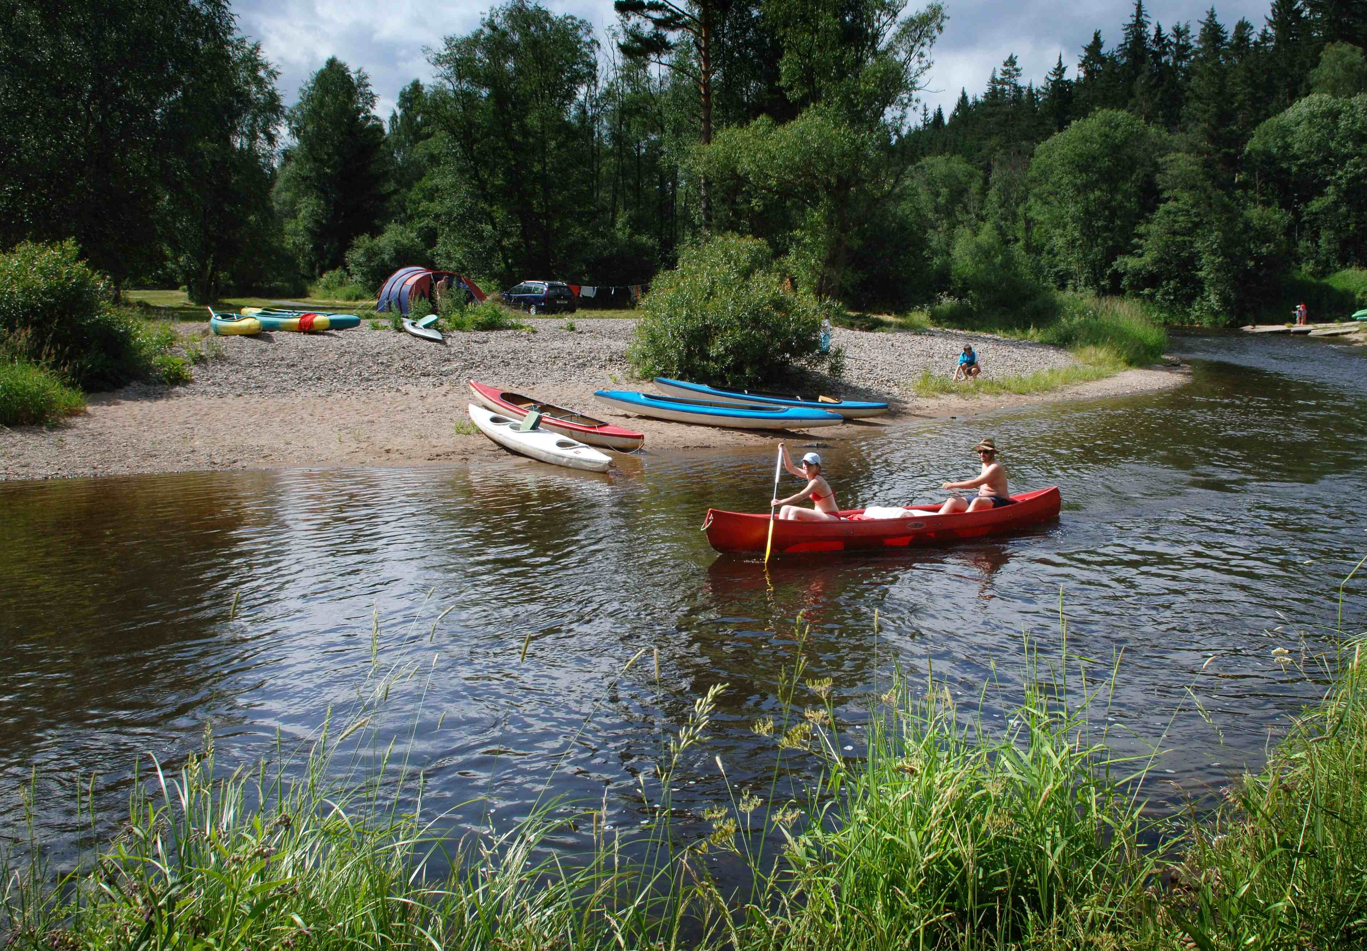 | 4D | Other?
- Place  - Transport  - Length  - Costs  - Accommodation  - Other | - seaside/mountains/lake/city/camp/tent/cottage  - by car/bus/coach/train/plane/bike; hitchhike  - one week/two weeks/longer?  - But I have only one week free.  - Isn’t it too expensive? I don’t have enough money.  - What shall we do if the weather is bad?  - So what have we agreed on?
A

Thank you very much. That is the end of the examination.

