The examiner is going to ask you some questions. Please answer the questions in as much detail as possible. If you don’t understand a question, please ask the examiner to repeat it.
12
TOPIC: Travelling – holidays, trips
PART ONE (2,5 min.) | Free time - holidays
Part Two consists of three tasks. Take the separate handout with pictures 2A and 2B in. The pictures show two different types of holidays.
PART TWO (4 min.) | Holidays
Look at pictures 2A and 2B on the separate handout. Choose one of the pictures and describe it.
Task One | 1,5 min.
The following ideas may help you:

- Place
- People
- Weather/Season
- Type of holiday
- Atmosphere
- Other
Look at both pictures once more and compare them (what is similar/the same/different?).
Task Two | 1 min.
The following ideas may help you:

- Place
- People
- Weather/Season
- Type of holiday
- Atmosphere
- Other

Task Three | 1,5 min.

Talk about your dream holiday.
A

Take the student's task sheet for PART THREE.
PART THREE (5 min.)
In Part Four of the exam, you and the examiner are going to talk together using pictures 4A–4C. Imagine the following situation:
PART FOUR (3 min.) | Free time - travelling
You and your friend would like to spend the next holidays together. First, you should choose a destination and then you should talk about other details of the holidays. The examiner will play the role of your friend and will start the dialogue.

The following ideas may help you:
A

- Place
- Transport
- Length
- Costs
- Accommodation
- Other
The following pictures may help you:

4A | 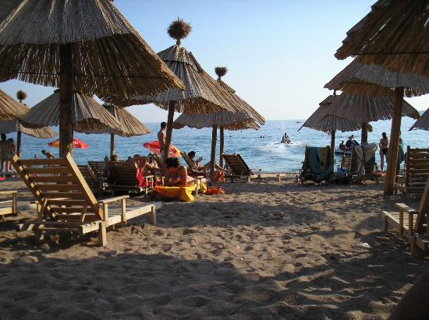 | 4B | 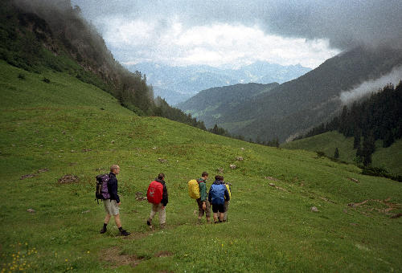
4C | 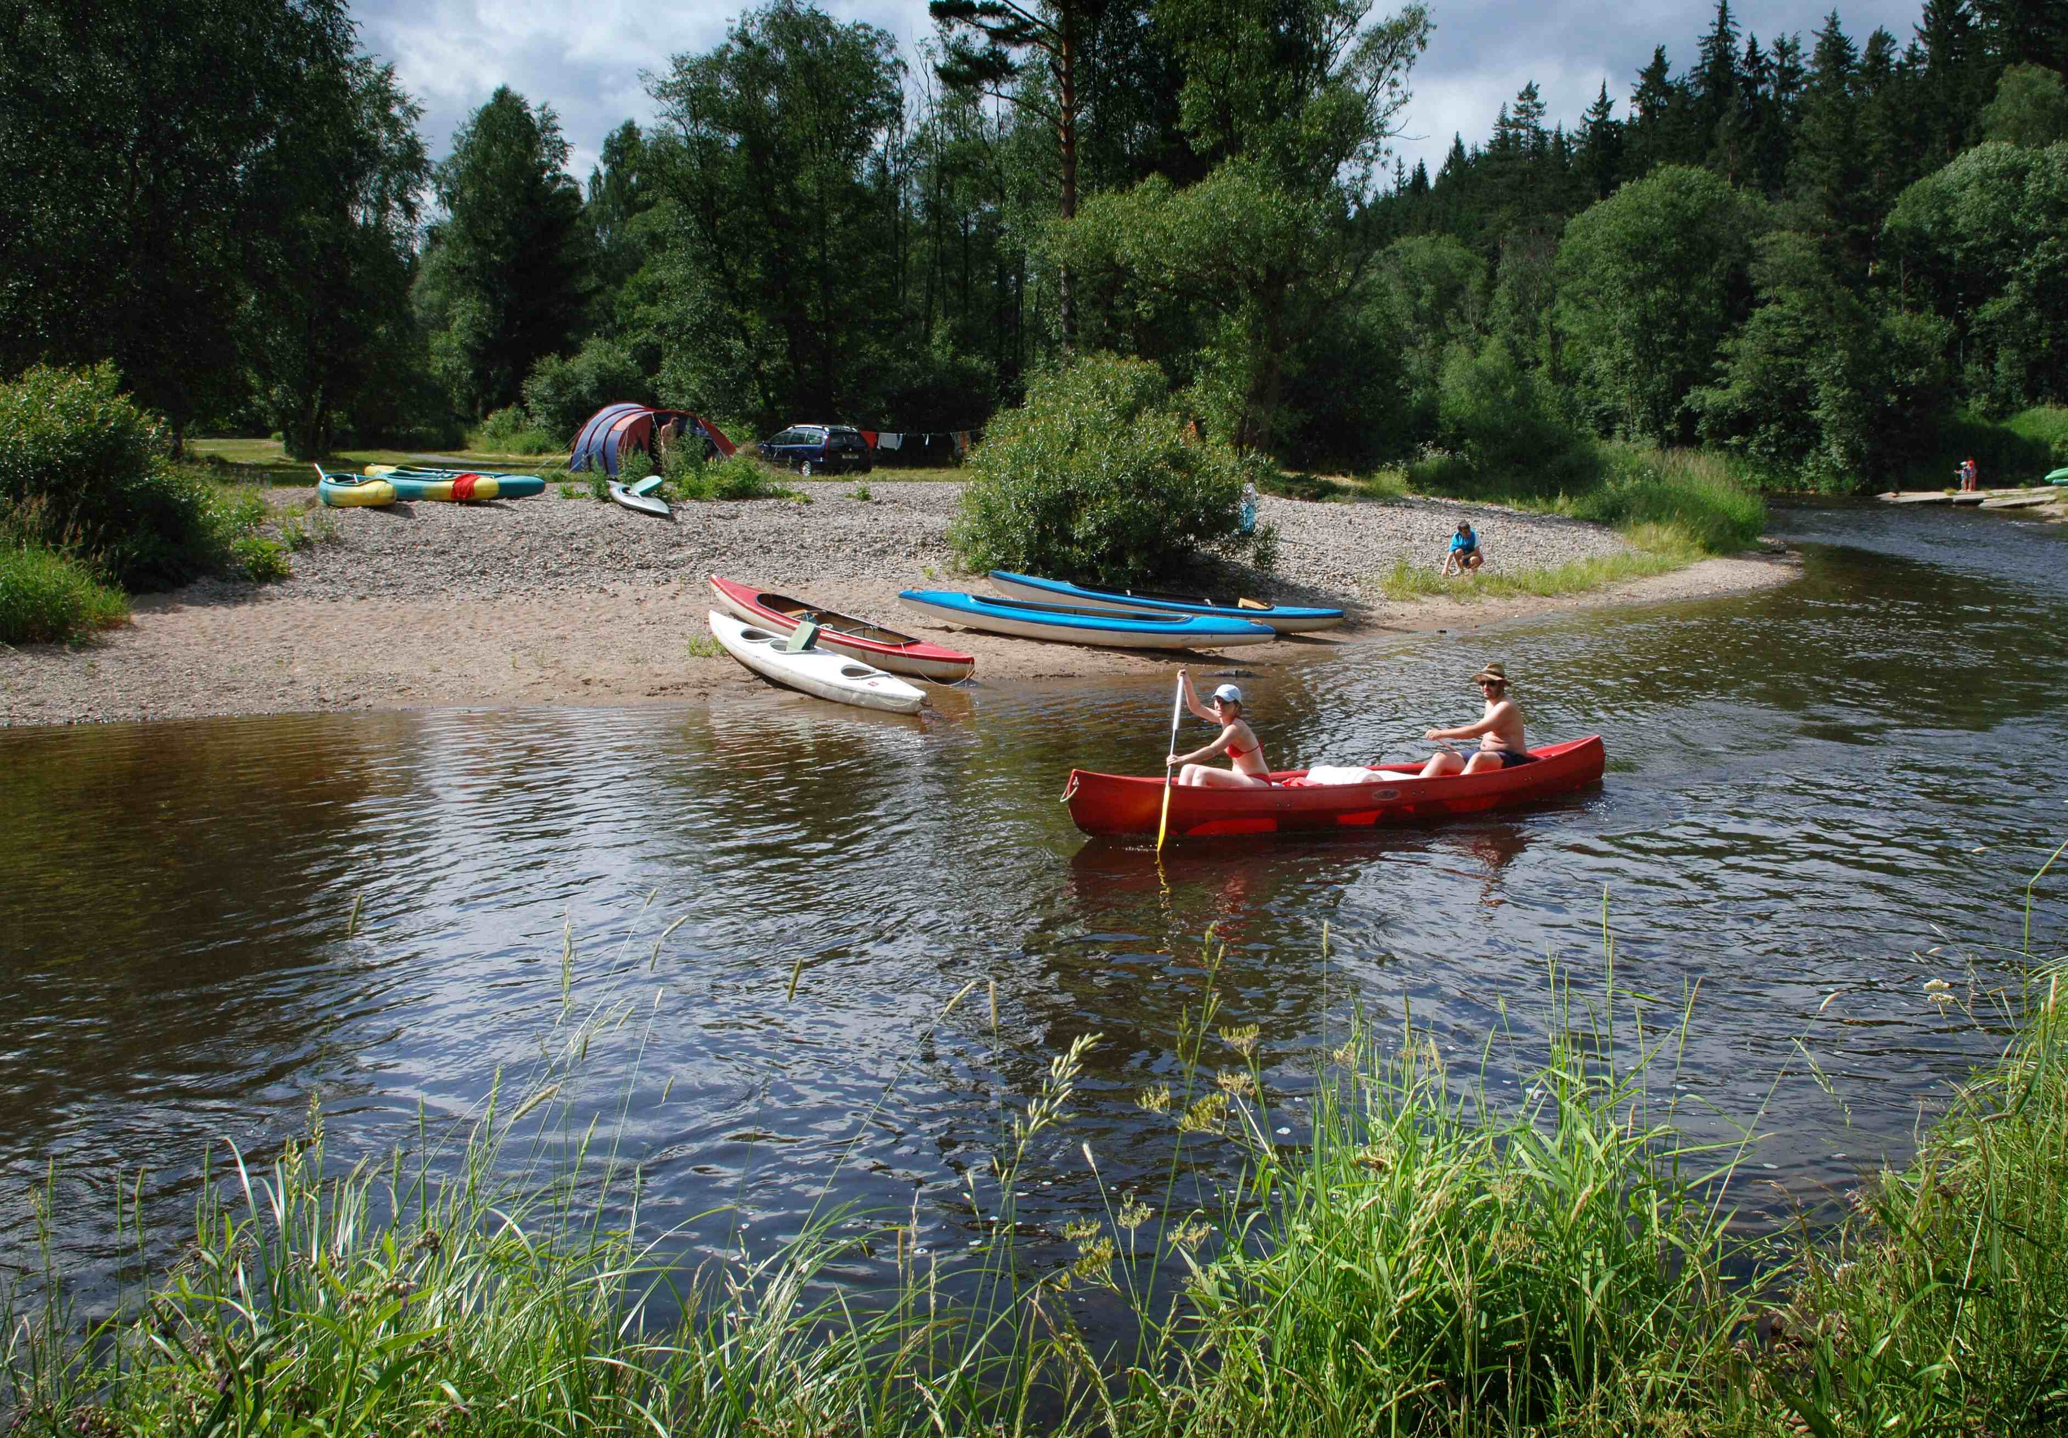 | 4D | Other?

