12
2A | 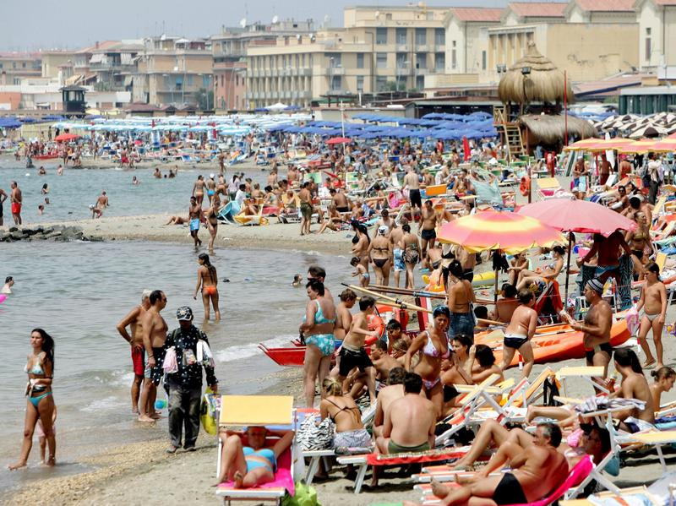
The following ideas may help you:

- Place
- People
- Weather/Season
- Type of holiday
- Atmosphere
- Other
2B | 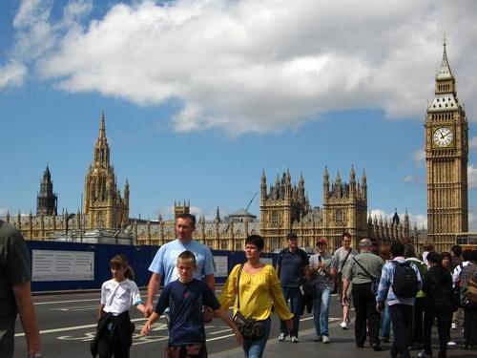
PART TWO | Travelling – holidays

A

