11
2A | 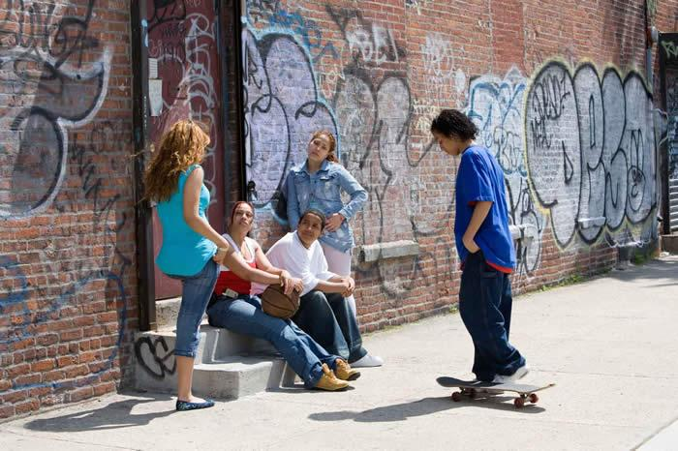
The following ideas may help you:

- Place
- People (appearance, age, clothes)
- Activities
- Lifestyle
- Atmosphere
- Other
2B | 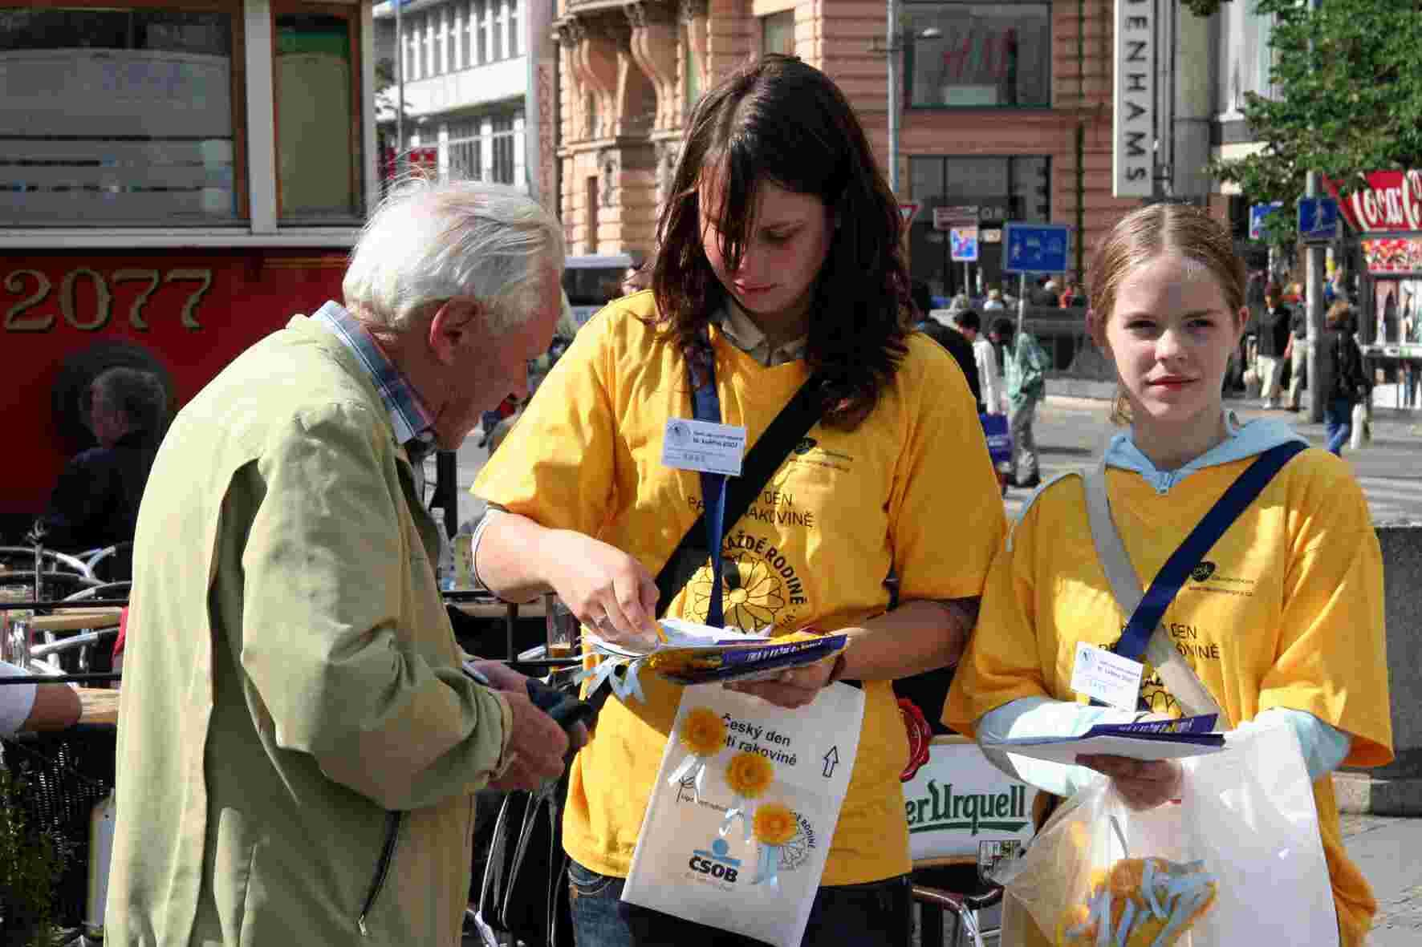
PART TWO | Interpersonal relationships

A

