10
PART TWO | Hobbies
2A | 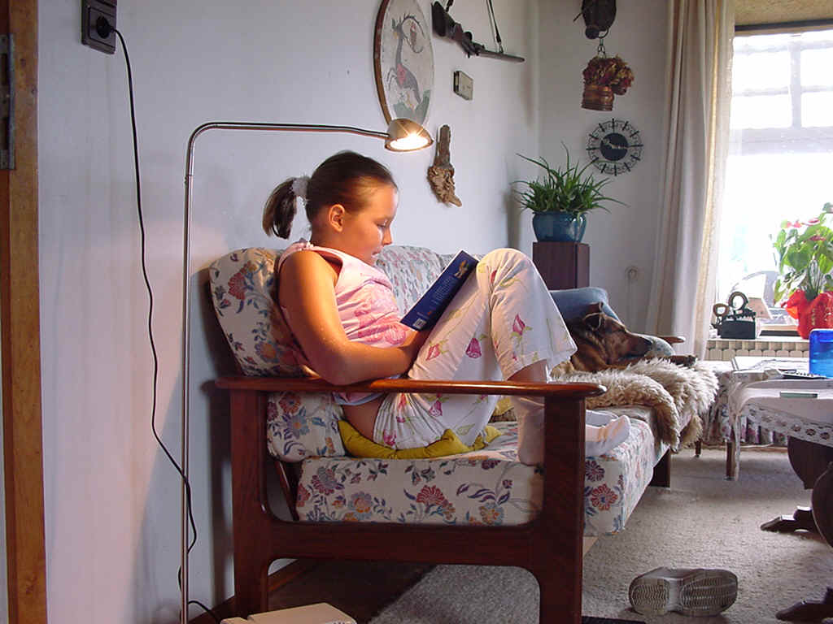
The following ideas may help you:

- Place
- People (clothes, appearance, etc.)
- Activities
- Equipment/Things you see
- Atmosphere
- Other
2B | 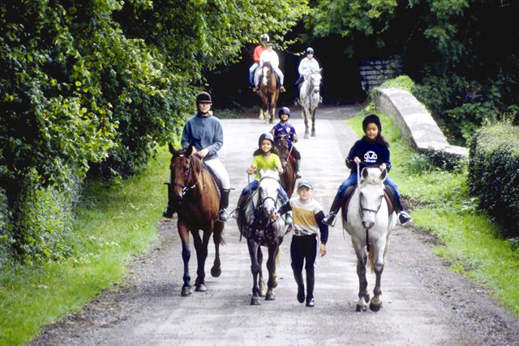

A

