9
PART TWO | Free time - music
2A | 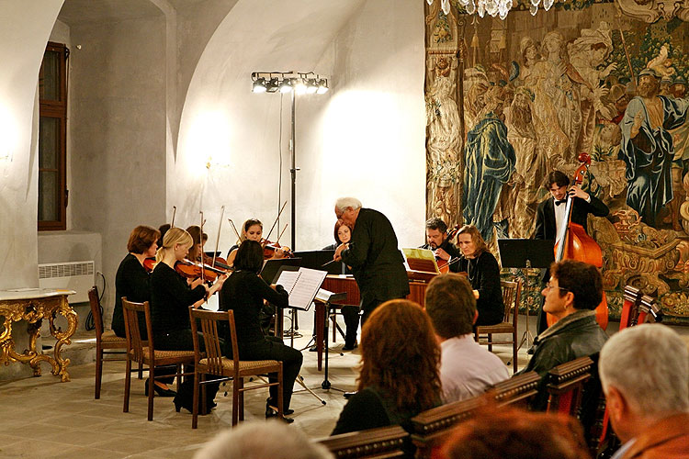
The following ideas may help you:

- Place
- People (age, clothes, etc.)
- Things you see
- Kind of music
- Atmosphere
- Other
2B | 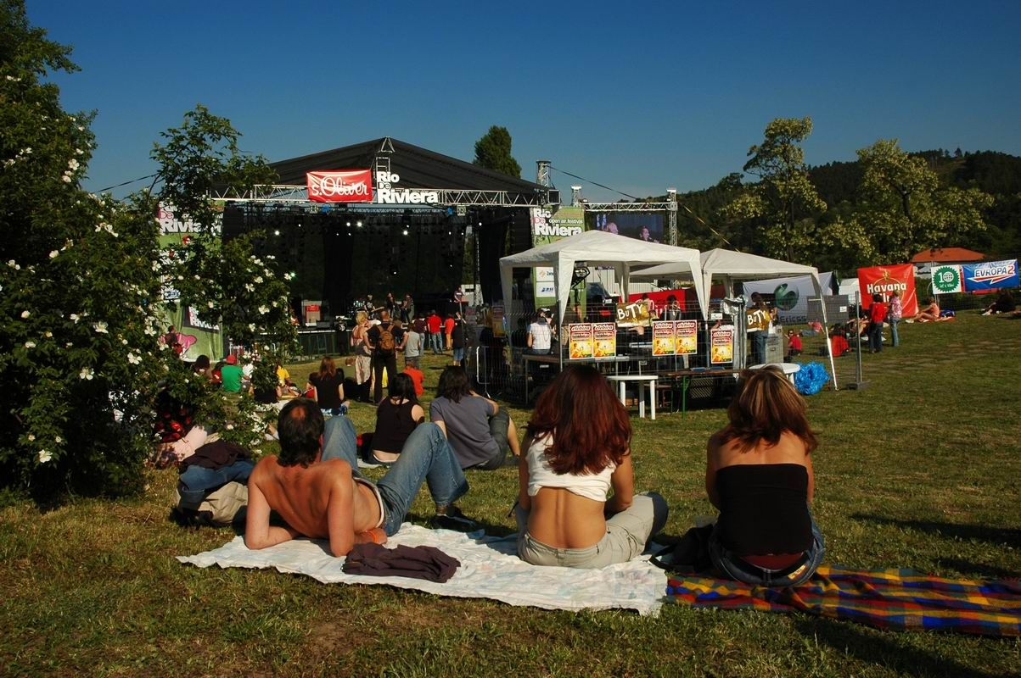

A

