Hello. (Sit down, please. Would you tell me your task sheet number so I can check it, please?)
8
TOPIC: TOPIC: Free time and entertainment – sport
INTRODUCTION | 0,5 min.

First, could you briefly introduce yourself to the committee?

Thank you.
Now, let’s go to Part One.
I am going to ask you some questions about the topic You and sports. If possible, give detailed answers. If you don’t understand a question, please ask me to repeat it.
PART ONE (3–5 Qs) | You and sports | 2,5 min.
Are you ready?

- Do you do any sport? Tell me more about it. / Why not?
- Did you like your P.E. lessons at school? Why?/Why not?
- Should everybody do sports? Why?/Why not?
- What do you think about adrenaline sports?
- Would you like to become a professional sportsman/sportswoman? Why?/Why not?
- What would you do if someone got injured during a sport activity?

Thank you. Now, let’s go to Part Two.
Look at pictures 2A and 2B on the separate handout.
PART TWO | Sport | 4 min.
Which picture would you like to talk about? … Describe it, please. Are you ready?
Task One | 1,5 min.
Thank you. Now, let’s go to Task Two.
- Place  - People (appearance, age, etc.)  - Clothes/Equipment  - Activities  - Atmosphere  - Other | - What sport are they doing?  - What skills do you need to do this sport?  - Is this sport attractive for you? Why?/Why not?
Have a look at both pictures once more. Now, I would like you to compare them.
Task Two | 1 min.
Are you ready?
Thank you. Now, let’s go to Task Three.
- Place  - People (appearance, age, etc.)  - Clothes/Equipment  - Activities  - Atmosphere  - Other | - Which sport would you prefer? Why?  - Which sport is more dangerous?  - Which sport is more active?
Now, tell me about your sport activities.
Task Three | 1,5 min.

- How often do you do sport? With whom?
- What equipment do you need?
- Do you prefer individual or team sports? Why?

Thank you. Now, let’s go to Part Three.
A

Now, please take the student's task sheet for part three.
PART THREE |  | 5 min.
Now we are going to talk together using pictures 4A–4C. Imagine the following situation:
PART FOUR | Doing sport together | 3 min.
We are friends, and we would like to start doing a sport regularly. First, we should agree on a sport and then talk about other details of the activity. I will play the role of your friend and will start the dialogue.
Are you ready?
- What?  - Where?  - How often?  - Equipment  - How much?  - Other | - What sport shall we start doing?  - I feel uncomfortable in swimming pools. / I am afraid of going downhill on in-line skates.  - That’s a great idea! / It’s a good idea, but I can’t swim/skate/even play tennis.  - Do you know any places in the city where we could do it? / Is it enough to do the activity once a week?  - What equipment will we need? / Can I borrow skates/a racket there?  - Isn’t it too expensive?  - So what have we agreed on?
A
Thank you very much. That is the end of the examination.
4A | 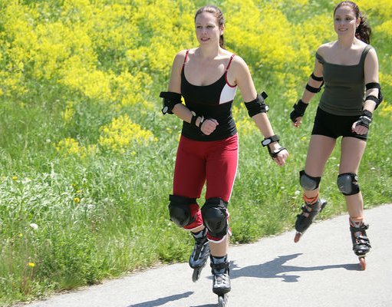 | 4B | 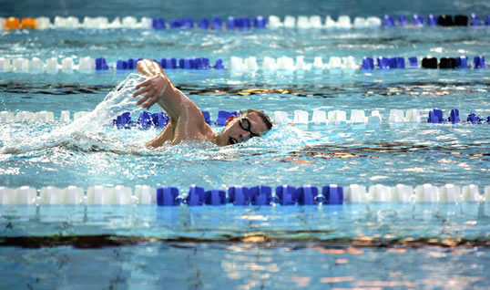
4C | 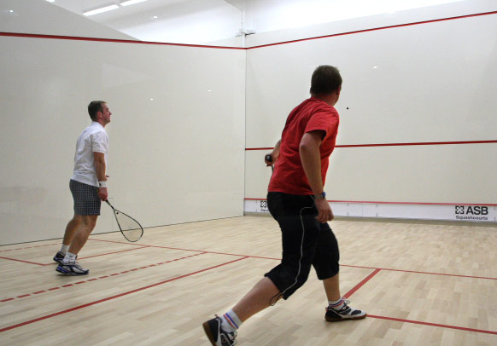 | 4D | OTHER?

