The examiner is going to ask you some questions. Please answer the questions in as much detail as possible. If you don’t understand a question, please ask the examiner to repeat it.
8
TOPIC: Free time and entertainment – sport
PART ONE (2,5 min.) | You and sports
Part Two consists of three tasks. Take the separate handout with pictures 2A and 2B. The pictures show two different kinds of sports.
PART TWO (4 min.) | Sport
Look at pictures 2A and 2B on the separate handout. Choose one of the pictures and describe it.
Task One | 1,5 min.
The following ideas may help you:

- Place
- People (appearance, age, etc.)
- Clothes/Equipment
- Activities
- Atmosphere
- Other
Look at both pictures once more and compare them (what is similar/the same/different?).
Task Two | 1 min.
The following ideas may help you:

- Place
- People (appearance, age, etc.)
- Clothes/Equipment
- Activities
- Atmosphere
- Other

A
Task Three | 1,5 min.
Talk about your sport activities.

Take the student's task sheet for PART THREE.
PART THREE (5 min.)
In Part Four of the exam, you and the examiner are going to talk together using pictures 4A–4C. Imagine the following situation:
PART FOUR (3 min.) | Doing sport together
You and your English speaking friend would like to start doing sport regularly. First, you should agree on a sport and then talk about the details of the activity. The examiner will play the role of your English speaking friend and will start the dialogue.

The following ideas may help you:
A

- What?
- Where?
- How often?
- Equipment
- How much?
- Other
The following pictures may help you:

4A | 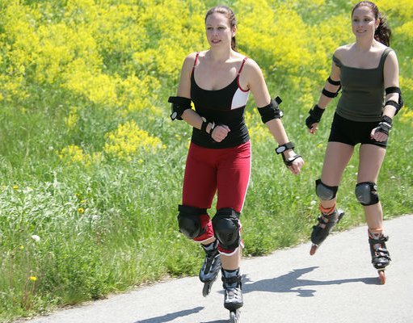 | 4B | 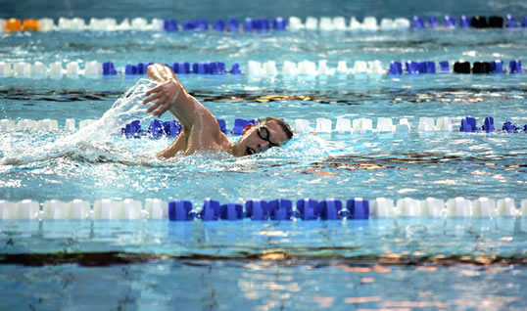
4C | 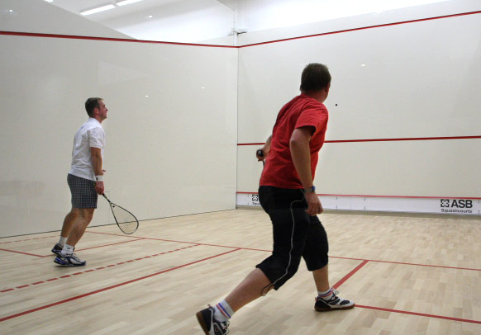 | 4D | OTHER?

