8
PART TWO | Sport
2A | 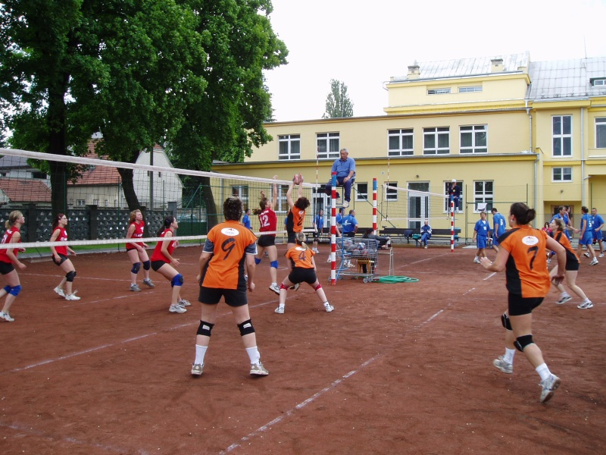
The following ideas may help you:

- Place
- People (appearance, age, etc.)
- Clothes/Equipment
- Activities
- Atmosphere
- Other
2B | 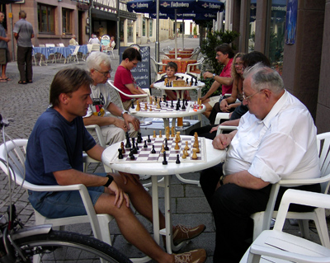

A

