7
PART TWO | Education and society
2A | 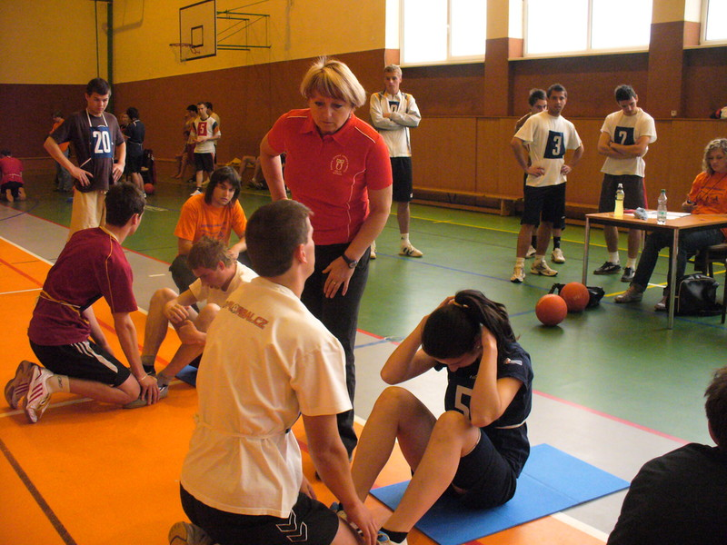
The following ideas may help you:

- Place
- People (clothes, age, etc.)
- Activities
- Furniture/Equipment
- Atmosphere
- Other
2B | 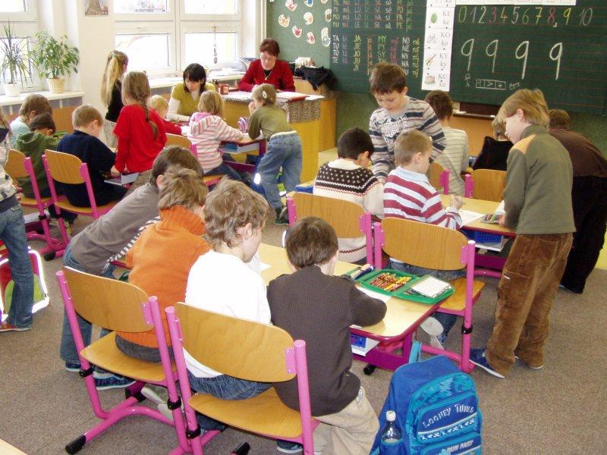

A

