5
PART TWO | Everyday life
2A | 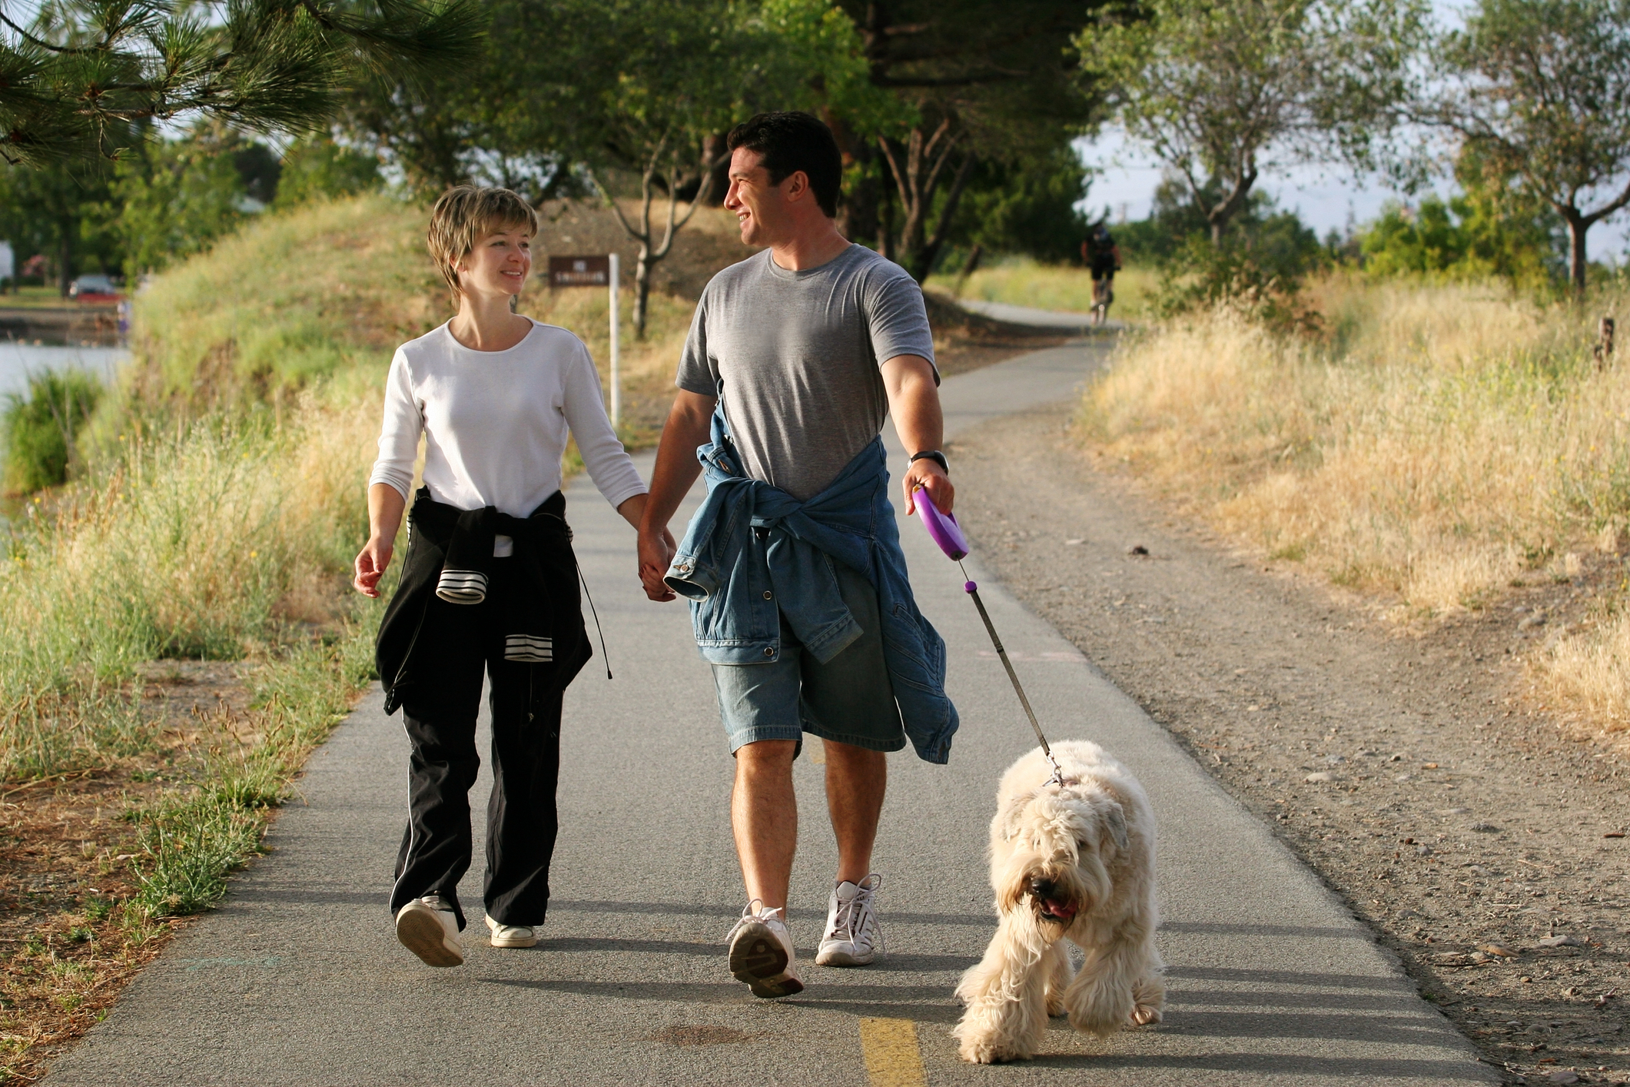
The following ideas may help you:

- Place
- Time of the day
- People (age, clothes, etc.)
- Activities
- Atmosphere
- Other
2B | 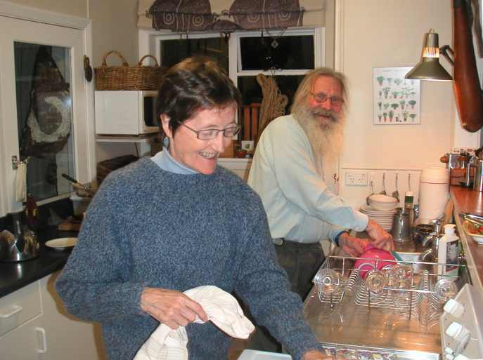

A

