4
PART TWO | Household chores
2A | 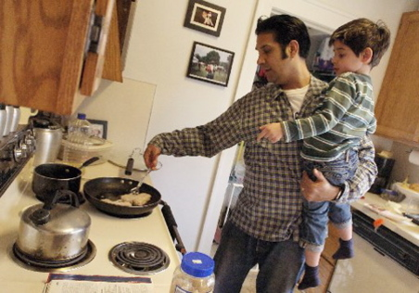
The following ideas may help you:

- Place
- People (gender, age, appearance, etc.)
- Activities
- Furniture/Equipment
- Atmosphere
- Other
2B | 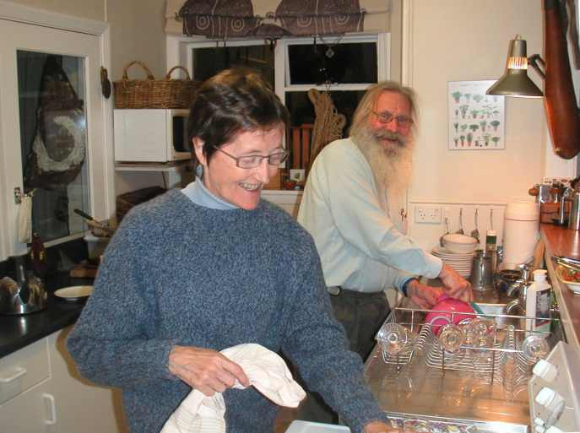

A

