3
PART TWO | Rooms
2A | 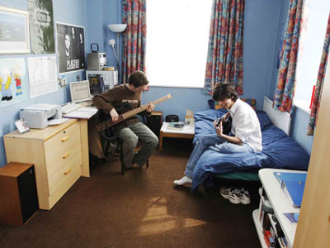
The following ideas may help you:

- Place/Space
- People (age, gender, clothes)
- Activities
- Furniture/Equipment
- Colour/Style
- Other
2B | 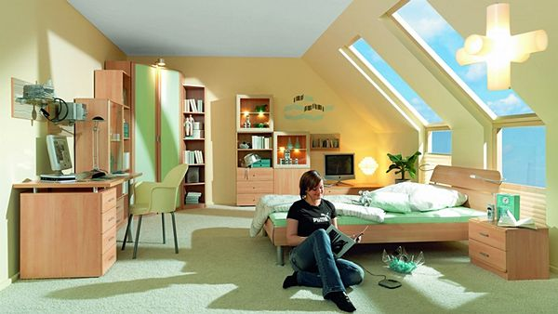

A

